Figure 1:
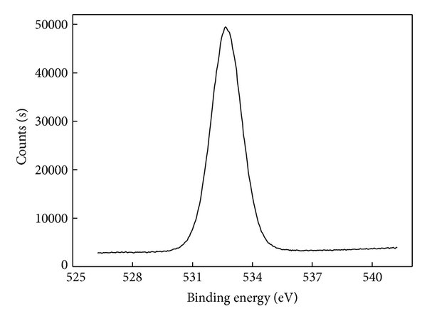
ChatGPT Data:
Binding Energy (eV) | Counts (s)
525.00 | 0
525.11 | 0
525.23 | 0
525.34 | 0
525.45 | 0
525.57 | 0
525.68 | 0
525.80 | 0
525.91 | 0
526.02 | 0
526.14 | 0
526.25 | 0
526.36 | 0
526.48 | 0
526.59 | 0
526.71 | 0
526.82 | 0
526.93 | 0
527.05 | 0
527.16 | 0
527.27 | 0
527.39 | 0
527.50 | 0
527.61 | 0
527.73 | 0
527.84 | 0
527.95 | 0
528.07 | 0
528.18 | 0
528.29 | 500
528.41 | 2000
528.52 | 5000
528.63 | 10000
528.75 | 15000
528.86 | 22000
528.98 | 28000
529.09 | 35000
529.20 | 41000
529.32 | 46000
529.43 | 49000
529.54 | 50000
529.66 | 49500
529.77 | 47000
529.89 | 43000
530.00 | 38000
530.11 | 32000
530.23 | 25000
530.34 | 18000
530.45 | 12000
530.57 | 7000
530.68 | 3000
530.80 | 1000
530.91 | 500
531.02 | 0
531.14 | 0
531.25 | 0
531.36 | 0
531.48 | 0
531.59 | 0
531.71 | 0
531.82 | 0
531.93 | 0
532.05 | 0
532.16 | 0
532.27 | 0
532.39 | 0
532.50 | 0
532.61 | 0
532.73 | 0
532.84 | 0
532.95 | 0
533.07 | 0
533.18 | 0
533.29 | 0
533.41 | 0
533.52 | 0
533.64 | 0
533.75 | 0
533.86 | 0
533.98 | 0
534.09 | 0
534.20 | 0
534.32 | 0
534.43 | 0
534.54 | 0
534.66 | 0
534.77 | 0
534.89 | 0
535.00 | 0
535.11 | 0
535.23 | 0
535.34 | 0
535.45 | 0
535.57 | 0
535.68 | 0
535.80 | 0
535.91 | 0
536.02 | 0
536.14 | 0
536.25 | 0
536.36 | 0
536.48 | 0
536.59 | 0
536.71 | 0
536.82 | 0
536.93 | 0
537.05 | 0
537.16 | 0
537.27 | 0
537.39 | 0
537.50 | 0
537.61 | 0
537.73 | 0
537.84 | 0
537.95 | 0
538.07 | 0
538.18 | 0
538.29 | 0
538.41 | 0
538.52 | 0
538.63 | 0
538.75 | 0
538.86 | 0
538.98 | 0
539.09 | 0
539.20 | 0
539.32 | 0
539.43 | 0
539.54 | 0
539.66 | 0
539.77 | 0
539.89 | 0
540.00 | 0

Perplexity Data:
Binding Energy (eV) | Counts (s)
525.00 | 3200
525.25 | 3200
525.50 | 3200
525.75 | 3200
526.00 | 3200
526.25 | 3200
526.50 | 3200
526.75 | 3200
527.00 | 3200
527.25 | 3200
527.50 | 3200
527.75 | 3200
528.00 | 3200
528.25 | 3200
528.50 | 3200
528.75 | 3200
529.00 | 3200
529.25 | 3200
529.50 | 3200
529.75 | 3200
530.00 | 3200
530.25 | 3200
530.50 | 3300
530.75 | 3400
531.00 | 3500
531.25 | 4000
531.50 | 5000
531.75 | 6500
532.00 | 9000
532.25 | 12000
532.50 | 16000
532.75 | 21000
533.00 | 27000
533.25 | 34000
533.50 | 41000
533.75 | 47000
534.00 | 49000
534.25 | 47000
534.50 | 41000
534.75 | 34000
535.00 | 27000
535.25 | 21000
535.50 | 16000
535.75 | 12000
536.00 | 9000
536.25 | 6500
536.50 | 5000
536.75 | 4000
537.00 | 3500
537.25 | 3400
537.50 | 3300
537.75 | 3200
538.00 | 3200
538.25 | 3200
538.50 | 3200
538.75 | 3200
539.00 | 3200
539.25 | 3200
539.50 | 3200
539.75 | 3200
540.00 | 3200

Gemini Data:
Binding Energy (eV) | Counts (s)
525.0 | 1500
525.5 | 1550
526.0 | 1600
526.5 | 1700
527.0 | 1850
527.5 | 2000
528.0 | 2250
528.5 | 2600
529.0 | 3200
529.5 | 4000
530.0 | 5500
530.2 | 6500
530.4 | 7800
530.6 | 9500
530.8 | 11500
531.0 | 14000
531.2 | 16800
531.4 | 20000
531.6 | 23500
531.8 | 27500
532.0 | 31500
532.2 | 35500
532.4 | 39000
532.6 | 42500
532.8 | 45500
532.9 | 47000
533.0 | 48500
533.1 | 49500
533.2 | 49900
533.3 | 49500
533.4 | 48000
533.5 | 46500
533.6 | 44000
533.7 | 41000
533.8 | 38000
533.9 | 34500
534.0 | 31000
534.1 | 27500
534.2 | 24000
534.3 | 20500
534.4 | 17500
534.5 | 15000
534.6 | 12800
534.8 | 10500
535.0 | 8500
535.2 | 7000
535.4 | 5800
535.6 | 4800
535.8 | 4000
536.0 | 3400
536.2 | 2900
536.4 | 2500
536.6 | 2200
536.8 | 2000
537.0 | 1850
537.2 | 1750
537.4 | 1680
537.6 | 1620
537.8 | 1580
538.0 | 1550
538.5 | 1500
539.0 | 1500
539.5 | 1550
540.0 | 1600
540.5 | 1650

Figure 2:
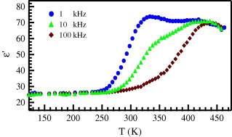
ChatGPT Data:
w(1 kHz) |  | w(10 kHz) |  | w(100 kHz)
T(K) | w | T(K) | w | T(K) | w
150 | 20.33464 | 150 | 20.17237 | 150 | 20.08865
153.0303 | 20.36995 | 153.0303 | 20.19062 | 153.0303 | 20.09805
156.0606 | 20.40895 | 156.0606 | 20.2108 | 156.0606 | 20.10845
159.0909 | 20.45202 | 159.0909 | 20.2331 | 159.0909 | 20.11995
162.1212 | 20.49958 | 162.1212 | 20.25775 | 162.1212 | 20.13267
165.1515 | 20.5521 | 165.1515 | 20.28499 | 165.1515 | 20.14672
168.1818 | 20.61006 | 168.1818 | 20.31509 | 168.1818 | 20.16227
171.2121 | 20.67403 | 171.2121 | 20.34834 | 171.2121 | 20.17945
174.2424 | 20.74461 | 174.2424 | 20.38508 | 174.2424 | 20.19845
177.2727 | 20.82245 | 177.2727 | 20.42567 | 177.2727 | 20.21945
180.303 | 20.90827 | 180.303 | 20.47048 | 180.303 | 20.24266
183.3333 | 21.00288 | 183.3333 | 20.51997 | 183.3333 | 20.26832
186.3636 | 21.10711 | 186.3636 | 20.5746 | 186.3636 | 20.29667
189.3939 | 21.22191 | 189.3939 | 20.6349 | 189.3939 | 20.32799
192.4242 | 21.34828 | 192.4242 | 20.70143 | 192.4242 | 20.3626
195.4545 | 21.48732 | 195.4545 | 20.77483 | 195.4545 | 20.40083
198.4848 | 21.64022 | 198.4848 | 20.85578 | 198.4848 | 20.44306
201.5152 | 21.80825 | 201.5152 | 20.94502 | 201.5152 | 20.48969
204.5455 | 21.99278 | 204.5455 | 21.04336 | 204.5455 | 20.54118
207.5758 | 22.19529 | 207.5758 | 21.15171 | 207.5758 | 20.59801
210.6061 | 22.41735 | 210.6061 | 21.27101 | 210.6061 | 20.66073
213.6364 | 22.66061 | 213.6364 | 21.40231 | 213.6364 | 20.72993
216.6667 | 22.92685 | 216.6667 | 21.54675 | 216.6667 | 20.80626
219.697 | 23.21791 | 219.697 | 21.70554 | 219.697 | 20.89043
222.7273 | 23.53575 | 222.7273 | 21.88 | 222.7273 | 20.98321
225.7576 | 23.88238 | 225.7576 | 22.07155 | 225.7576 | 21.08545
228.7879 | 24.25987 | 228.7879 | 22.28168 | 228.7879 | 21.19806
231.8182 | 24.67035 | 231.8182 | 22.51201 | 231.8182 | 21.32203
234.8485 | 25.11596 | 234.8485 | 22.76424 | 234.8485 | 21.45844
237.8788 | 25.59884 | 237.8788 | 23.04019 | 237.8788 | 21.60847
240.9091 | 26.12107 | 240.9091 | 23.34172 | 240.9091 | 21.77337
243.9394 | 26.68469 | 243.9394 | 23.67083 | 243.9394 | 21.95449
246.9697 | 27.29157 | 246.9697 | 24.02955 | 246.9697 | 22.15328
250 | 27.94346 | 250 | 24.41998 | 250 | 22.37129
253.0303 | 28.64182 | 253.0303 | 24.84426 | 253.0303 | 22.61018
256.0606 | 29.38788 | 256.0606 | 25.30452 | 256.0606 | 22.87167
259.0909 | 30.1825 | 259.0909 | 25.80289 | 259.0909 | 23.15762
262.1212 | 31.02611 | 262.1212 | 26.34144 | 262.1212 | 23.46995
265.1515 | 31.91869 | 265.1515 | 26.92215 | 265.1515 | 23.81065
268.1818 | 32.85968 | 268.1818 | 27.54684 | 268.1818 | 24.1818
271.2121 | 33.84795 | 271.2121 | 28.21715 | 271.2121 | 24.58551
274.2424 | 34.88174 | 274.2424 | 28.93447 | 274.2424 | 25.02392
277.2727 | 35.95864 | 277.2727 | 29.69987 | 277.2727 | 25.49918
280.303 | 37.07558 | 280.303 | 30.51405 | 280.303 | 26.01338
283.3333 | 38.22882 | 283.3333 | 31.37728 | 283.3333 | 26.56856
286.3636 | 39.41403 | 286.3636 | 32.28933 | 286.3636 | 27.16665
289.3939 | 40.62627 | 289.3939 | 33.2494 | 289.3939 | 27.8094
292.4242 | 41.8601 | 292.4242 | 34.25613 | 292.4242 | 28.49837
295.4545 | 43.10968 | 295.4545 | 35.30749 | 295.4545 | 29.23481
298.4848 | 44.36882 | 298.4848 | 36.4008 | 298.4848 | 30.01966
301.5152 | 45.63118 | 301.5152 | 37.53275 | 301.5152 | 30.85346
304.5455 | 46.89032 | 304.5455 | 38.69933 | 304.5455 | 31.73627
307.5758 | 48.1399 | 307.5758 | 39.89598 | 307.5758 | 32.66766
310.6061 | 49.37373 | 310.6061 | 41.11753 | 310.6061 | 33.64659
313.6364 | 50.58597 | 313.6364 | 42.35838 | 313.6364 | 34.67145
316.6667 | 51.77118 | 316.6667 | 43.61254 | 316.6667 | 35.73995
319.697 | 52.92442 | 319.697 | 44.87374 | 319.697 | 36.84916
322.7273 | 54.04136 | 322.7273 | 46.13558 | 322.7273 | 37.99547
325.7576 | 55.11826 | 325.7576 | 47.39165 | 325.7576 | 39.17466
328.7879 | 56.15205 | 328.7879 | 48.63566 | 328.7879 | 40.38191
331.8182 | 57.14032 | 331.8182 | 49.86153 | 331.8182 | 41.61188
334.8485 | 58.08131 | 334.8485 | 51.06359 | 334.8485 | 42.85879
337.8788 | 58.97389 | 337.8788 | 52.23657 | 337.8788 | 44.11653
340.9091 | 59.8175 | 340.9091 | 53.37578 | 340.9091 | 45.37876
343.9394 | 60.61212 | 343.9394 | 54.47711 | 343.9394 | 46.63906
346.9697 | 61.35818 | 346.9697 | 55.53709 | 346.9697 | 47.89105
350 | 62.05654 | 350 | 56.55293 | 350 | 49.12851
353.0303 | 62.70843 | 353.0303 | 57.52247 | 353.0303 | 50.34552
356.0606 | 63.31531 | 356.0606 | 58.4442 | 356.0606 | 51.53654
359.0909 | 63.87893 | 359.0909 | 59.31723 | 359.0909 | 52.69655
362.1212 | 64.40116 | 362.1212 | 60.14121 | 362.1212 | 53.82106
365.1515 | 64.88404 | 365.1515 | 60.91633 | 365.1515 | 54.90624
368.1818 | 65.32965 | 368.1818 | 61.64319 | 368.1818 | 55.94886
371.2121 | 65.74013 | 371.2121 | 62.3228 | 371.2121 | 56.9464
374.2424 | 66.11762 | 374.2424 | 62.95649 | 374.2424 | 57.89696
377.2727 | 66.46425 | 377.2727 | 63.54585 | 377.2727 | 58.79929
380.303 | 66.78209 | 380.303 | 64.09268 | 380.303 | 59.65271
383.3333 | 67.07315 | 383.3333 | 64.59892 | 383.3333 | 60.4571
386.3636 | 67.33939 | 386.3636 | 65.06664 | 386.3636 | 61.21281
389.3939 | 67.58265 | 389.3939 | 65.49794 | 389.3939 | 61.92063
392.4242 | 67.80471 | 392.4242 | 65.89497 | 392.4242 | 62.5817
395.4545 | 68.00722 | 395.4545 | 66.25986 | 395.4545 | 63.19746
398.4848 | 68.19175 | 398.4848 | 66.59472 | 398.4848 | 63.76958
401.5152 | 68.35978 | 401.5152 | 66.90162 | 401.5152 | 64.29993
404.5455 | 68.51268 | 404.5455 | 67.18252 | 404.5455 | 64.79051
407.5758 | 68.65172 | 407.5758 | 67.43935 | 407.5758 | 65.24341
410.6061 | 68.77809 | 410.6061 | 67.67392 | 410.6061 | 65.66074
413.6364 | 68.89289 | 413.6364 | 67.88796 | 413.6364 | 66.04466
416.6667 | 68.99712 | 416.6667 | 68.0831 | 416.6667 | 66.39729
419.697 | 69.09173 | 419.697 | 68.26086 | 419.697 | 66.72073
422.7273 | 69.17755 | 422.7273 | 68.42268 | 422.7273 | 67.01699
425.7576 | 69.25539 | 425.7576 | 68.56989 | 425.7576 | 67.28804
428.7879 | 69.32597 | 428.7879 | 68.70373 | 428.7879 | 67.53575
431.8182 | 69.38994 | 431.8182 | 68.82534 | 431.8182 | 67.76191
434.8485 | 69.4479 | 434.8485 | 68.9358 | 434.8485 | 67.9682
437.8788 | 69.50042 | 437.8788 | 69.03607 | 437.8788 | 68.15621
440.9091 | 69.54798 | 440.9091 | 69.12706 | 440.9091 | 68.32743
443.9394 | 69.59105 | 443.9394 | 69.20961 | 443.9394 | 68.48325
446.9697 | 69.63005 | 446.9697 | 69.28446 | 446.9697 | 68.62496
450 | 69.66536 | 450 | 69.35231 | 450 | 68.75378

Perplexity Data:
w(1 kHz) |  | w(10 kHz) |  | w(100 kHz)
T(K) | w | T(K) | w | T(K) | w
140 | 25 | 140 | 25 | 140 | 25
150 | 25 | 150 | 25 | 150 | 25
160 | 25 | 160 | 25 | 160 | 25
170 | 25 | 170 | 25 | 170 | 25
180 | 25 | 180 | 25 | 180 | 25
190 | 25 | 190 | 25 | 190 | 25
200 | 25 | 200 | 25 | 200 | 25
210 | 25 | 210 | 25 | 210 | 25
220 | 25 | 220 | 25 | 220 | 25
230 | 25 | 230 | 25 | 230 | 25
240 | 27 | 240 | 26 | 240 | 25
250 | 28 | 250 | 27 | 250 | 26
260 | 30 | 260 | 28 | 260 | 27
270 | 32 | 270 | 30 | 270 | 28
280 | 35 | 280 | 32 | 280 | 30
290 | 40 | 290 | 35 | 290 | 32
300 | 50 | 300 | 40 | 300 | 35
310 | 60 | 310 | 45 | 310 | 38
320 | 70 | 320 | 50 | 320 | 40
330 | 73 | 330 | 55 | 330 | 42
340 | 74 | 340 | 60 | 340 | 45
350 | 73 | 350 | 63 | 350 | 50
360 | 72 | 360 | 65 | 360 | 55
370 | 71 | 370 | 66 | 370 | 60
380 | 70 | 380 | 67 | 380 | 63
390 | 70 | 390 | 68 | 390 | 65
400 | 70 | 400 | 69 | 400 | 67
410 | 70 | 410 | 70 | 410 | 68
420 | 70 | 420 | 70 | 420 | 69
430 | 69 | 430 | 70 | 430 | 70
440 | 68 | 440 | 69 | 440 | 70
450 | 67 | 450 | 68 | 450 | 69

Gemini Data:

T (K) | Epsilon_prime_1kHz | Epsilon_prime_10kHz | Epsilon_prime_100kHz
130 | 26 | 26 | 26
140 | 26 | 26 | 26
150 | 26 | 26 | 26
160 | 26 | 26 | 26
170 | 26 | 26 | 26
180 | 26 | 26 | 26
190 | 26 | 26 | 26
200 | 26 | 26 | 26
210 | 26.5 | 26 | 26
220 | 27 | 26.5 | 26.5
230 | 27.5 | 26.5 | 26.5
240 | 28.5 | 27 | 27
250 | 30 | 27.5 | 27.5
260 | 33 | 28 | 28
270 | 38 | 29 | 28.5
280 | 45 | 30 | 29
290 | 52 | 31.5 | 30
300 | 59 | 33.5 | 30.5
310 | 65 | 36 | 31.5
320 | 70 | 39 | 32.5
330 | 73 | 43 | 34
340 | 74 | 47 | 35.5
350 | 73.5 | 52 | 37.5
360 | 72.5 | 57 | 40
370 | 71.5 | 61.5 | 43
380 | 70.5 | 65 | 47
390 | 69.5 | 68 | 52
400 | 68.5 | 70 | 57
410 | 68 | 71.5 | 62
420 | 67.5 | 72 | 66
430 | 67 | 71.5 | 68.5
440 | 66.5 | 70.5 | 69.5
450 | 66 | 68.5 | 69
460 | 65.5 | 67 | 67.5

Figure 3:

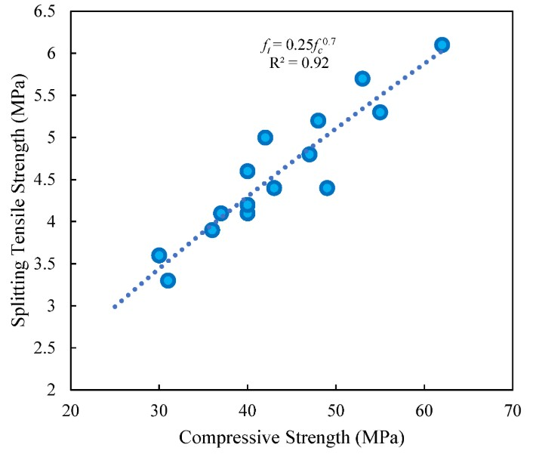
ChatGPT Data:
Compressive Strength (Mpa) | Splitting Tensile Strength (Mpa)
25 | 3
26 | 3.1
27 | 3.2
28 | 3.3
29 | 3.4
30 | 3.5
31 | 3.6
32 | 3.7
33 | 3.75
34 | 3.8
35 | 3.85
36 | 4
37 | 4.1
38 | 4.2
39 | 4.3
40 | 4.4
41 | 4.45
42 | 4.5
43 | 4.55
44 | 4.6
45 | 4.65
46 | 4.7
47 | 4.75
48 | 4.8
49 | 4.85
50 | 4.9
51 | 4.95
52 | 5
53 | 5.1
54 | 5.2
55 | 5.3
56 | 5.4
57 | 5.45
58 | 5.5
59 | 5.55
60 | 5.6
61 | 5.65
62 | 5.7
63 | 5.75
64 | 5.8
65 | 5.85
66 | 5.9
67 | 5.95
68 | 6
69 | 6.05
70 | 6.1
71 | 6.15
72 | 6.2
73 | 6.25
74 | 6.3
75 | 6.35
76 | 6.4
77 | 6.45
78 | 6.5
79 | 6.55
80 | 6.6
81 | 6.65
82 | 6.7
83 | 6.75
84 | 6.8
85 | 6.85

Perplexity Data:
Compressive Strength (Mpa) | Splitting Tensile Strength (Mpa)
27 | 3
28 | 3.2
29 | 3.3
30 | 3.6
31 | 3.7
31.5 | 3.8
32 | 3.8
32.5 | 3.9
33 | 3.9
33.5 | 4
34 | 4
34.5 | 4
35 | 4.1
35.5 | 4.1
36 | 4.1
36.5 | 4.2
37 | 4.2
37.5 | 4.2
38 | 4.3
38.5 | 4.3
39 | 4.3
39.5 | 4.4
40 | 4.5
40.5 | 4.5
41 | 4.5
41.5 | 4.6
42 | 4.6
42.5 | 4.7
43 | 4.7
43.5 | 4.7
44 | 4.8
44.5 | 4.8
45 | 4.9
45.5 | 4.9
46 | 5
46.5 | 5
47 | 5.1
47.5 | 5.1
48 | 5.2
48.5 | 5.2
49 | 5.3
49.5 | 5.3
50 | 5.3
50.5 | 5.4
51 | 5.4
51.5 | 5.5
52 | 5.5
52.5 | 5.6
53 | 5.6
53.5 | 5.7
54 | 5.7
54.5 | 5.8
55 | 5.8
55.5 | 5.9
56 | 5.9
56.5 | 6
57 | 6
57.5 | 6.1
58 | 6.1
58.5 | 6.2
59 | 6.2

Gemini Data:
Compressive Strength (Mpa) | Splitting Tensile Strength (Mpa)
24.76489913 | 2.978784301
25.63439102 | 3.050694583
25.87931831 | 3.060936997
26.39366562 | 3.121431255
27.16518659 | 3.185566371
27.93670756 | 3.256311044
28.70822853 | 3.323825623
29.40627131 | 3.389334396
29.6511986 | 3.392535151
29.90837226 | 3.598165838
30.16554592 | 3.464480997
30.3798573 | 3.520992093
30.42271957 | 3.464232049
30.76561778 | 3.538916318
31.02279144 | 3.31187614
31.10851599 | 3.526966835
31.72287528 | 3.592688991
31.96576151 | 3.603144789
32.48010882 | 3.661398519
32.73728248 | 3.661398519
33.27067969 | 3.720648039
33.50880345 | 3.728614361
34.02315076 | 3.795830203
34.28032442 | 3.795830203
34.75180946 | 3.869020786
35.30901904 | 3.930261887
35.70906695 | 3.960135594
36.12340229 | 3.990756145
36.12340229 | 3.901508443
36.42343822 | 4.032429967
36.85206098 | 4.054835247
37.29973364 | 4.065689361
37.3664083 | 4.018090587
37.73073764 | 4.107263604
37.62358195 | 4.060212515
38.0350598 | 4.115329505
38.68442328 | 4.179520634
39.10947419 | 4.196137884
39.44284745 | 4.232899141
39.8202736 | 4.245989634
40.02386941 | 4.614618738
40.06673169 | 4.198565123
40.06673169 | 4.099421756
40.10959396 | 4.526242353
40.15245624 | 4.565078173
40.29328943 | 4.31243196
40.15245624 | 4.261860041
40.19531852 | 4.056478301
40.53821672 | 4.320113771
41.0648104 | 4.377513966
41.30973769 | 4.373886444
41.85623171 | 4.438675047
41.95267183 | 5.004595095
41.95267183 | 4.935138725
42.3041425 | 4.427360381
42.33843232 | 4.408241208
42.63234507 | 4.496155262
42.6670431 | 4.44222255
43.02422874 | 4.48053558
43.0027976 | 4.409734893
43.10995329 | 4.365671175
43.4528515 | 4.574637759

Figure 4:
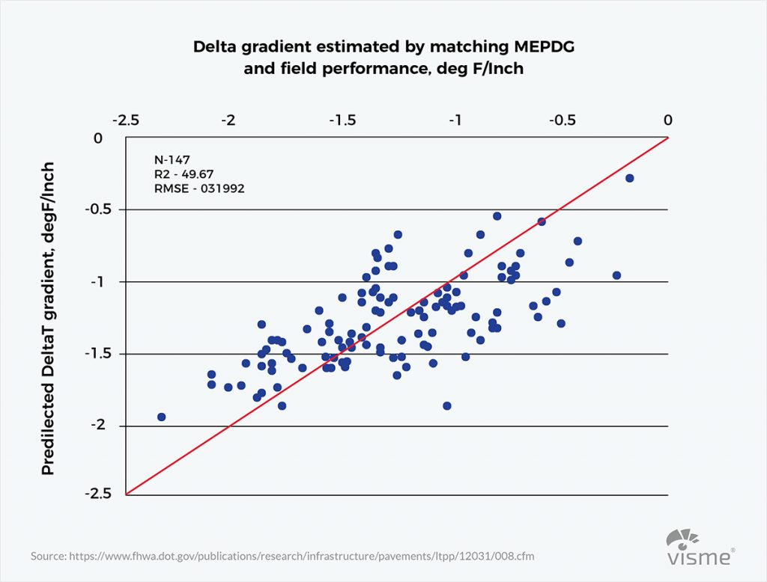

ChatGPT Data:
Delta gradient estimated by matching MEPDG and field performance | degF/inch
-1.12797 | -1.06129
-0.71203 | -0.58147
-0.99309 | -1.00682
-1.13779 | -1.12282
-1.44086 | -1.72152
-0.88526 | -0.79905
-1.40603 | -1.2979
-0.27057 | -0.14812
-0.09084 | -0.67306
-1.5414 | -1.10795
-0.52069 | -0.46283
-1.17776 | -1.30402
-1.07989 | -0.55781
-0.18601 | -0.29523
-2.32241 | -1.91922
-2.28218 | -2.52764
-2.44945 | -2.42464
-0.41845 | -0.80577
-0.55461 | -0.75294
-0.32497 | -0.67903
-0.05345 | 0.005839
-0.5021 | -0.37793
-1.3463 | -0.98711
-0.54868 | 0.016329
-2.20431 | -1.99005
-0.9002 | -0.2149
-2.14162 | -1.67239
-0.13833 | 0.045003
-1.19538 | -1.45859
-1.46335 | -1.94967
-1.83861 | -2.01311
-0.56442 | -0.72577
-1.35962 | -1.82643
-1.07892 | -1.09525
-2.45303 | -2.99641
-0.95591 | -1.14526
-0.96976 | -1.24821
-0.95767 | -0.51045
-0.14063 | -0.08198
-0.79545 | -0.93693
-1.60123 | -1.05752
-1.40742 | -2.09566
-0.75592 | -0.56056
-2.34944 | -2.68859
-0.83308 | -1.06629
-0.82341 | -0.48862
-1.97404 | -1.57221
-2.17768 | -2.70791
-1.71143 | -1.58411
-1.59072 | -1.26393
-1.07451 | -1.18976
-1.4035 | -1.21384
-0.02907 | -0.19396
-2.24489 | -2.08855
-1.97781 | -1.9453
-2.09673 | -2.01823
-0.86723 | -1.14166
-1.86677 | -1.6093
-1.33422 | -1.30592
-1.88894 | -2.33471
-2.10258 | -2.67275

Perplexity Data:
Delta gradient estimated by matching MEPDG and field performance | degF/inch
-1.12797 | -1.01684
-0.71203 | -0.49444
-0.99309 | -1.01597
-1.13779 | -1.11284
-1.44086 | -1.90863
-0.88526 | -0.74157
-1.40603 | -1.22582
-0.27057 | -0.06649
-0.09084 | -1.0612
-1.5414 | -0.81898
-0.52069 | -0.42426
-1.17776 | -1.3882
-1.07989 | -0.20976
-0.18601 | -0.36805
-2.32241 | -1.65043
-2.28218 | -2.5
-2.44945 | -2.4081
-0.41845 | -1.06398
-0.55461 | -0.88516
-0.32497 | -0.91507
-0.05345 | 0
-0.5021 | -0.29515
-1.3463 | -0.74764
-0.54868 | 0
-2.20431 | -1.8472
-0.9002 | 0
-2.14162 | -1.35957
-0.13833 | 0
-1.19538 | -1.63406
-1.46335 | -2.27389
-1.83861 | -2.12945
-0.56442 | -0.83333
-1.35962 | -2.13764
-1.07892 | -1.10615
-2.45303 | -2.5
-0.95591 | -1.2715
-0.96976 | -1.43384
-0.95767 | -0.2123
-0.14063 | -0.04288
-0.79545 | -1.03125
-1.60123 | -0.69505
-1.40742 | -2.5
-0.75592 | -0.43032
-2.34944 | -2.5
-0.83308 | -1.22176
-0.82341 | -0.26544
-1.97404 | -1.30432
-2.17768 | -2.5
-1.71143 | -1.49922
-1.59072 | -1.04607
-1.07451 | -1.2666
-1.4035 | -1.0874
-0.02907 | -0.30389
-2.24489 | -1.98433
-1.97781 | -1.92363
-2.09673 | -1.96589
-0.86723 | -1.32461
-1.86677 | -1.43765
-1.33422 | -1.28706
-1.88894 | -2.5
-2.10258 | -2.5

Gemini Data:
Delta gradient estimated by matching MEPDG and field performance | degF/inch
-0.1 | -0.2
-0.2 | -0.1
-0.25 | -0.3
-0.3 | -0.2
-0.3 | -0.4
-0.35 | -0.3
-0.4 | -0.3
-0.4 | -0.5
-0.45 | -0.4
-0.45 | -0.6
-0.5 | -0.4
-0.5 | -0.55
-0.5 | -0.7
-0.55 | -0.5
-0.55 | -0.65
-0.6 | -0.5
-0.6 | -0.6
-0.6 | -0.7
-0.6 | -0.8
-0.65 | -0.6
-0.65 | -0.75
-0.7 | -0.6
-0.7 | -0.8
-0.7 | -0.9
-0.75 | -0.7
-0.75 | -0.85
-0.8 | -0.7
-0.8 | -0.8
-0.8 | -0.95
-0.8 | -1.05
-0.85 | -0.75
-0.85 | -0.9
-0.9 | -0.8
-0.9 | -1.0
-0.9 | -1.1
-0.95 | -0.8
-0.95 | -0.9
-0.95 | -1.05
-0.95 | -1.2
-1.0 | -0.9
-1.0 | -1.0
-1.0 | -1.15
-1.0 | -1.25
-1.05 | -0.95
-1.05 | -1.1
-1.05 | -1.2
-1.1 | -1.0
-1.1 | -1.1
-1.1 | -1.2
-1.1 | -1.35
-1.15 | -1.05
-1.15 | -1.15
-1.15 | -1.3
-1.15 | -1.4
-1.2 | -1.1
-1.2 | -1.25
-1.2 | -1.4
-1.25 | -1.15
-1.25 | -1.3
-1.25 | -1.45
-1.25 | -1.55
-1.3 | -1.2
-1.3 | -1.35
-1.3 | -1.5
-1.3 | -1.6
-1.35 | -1.25
-1.35 | -1.4
-1.35 | -1.5
-1.35 | -1.65
-1.4 | -1.3
-1.4 | -1.45
-1.4 | -1.6
-1.4 | -1.7
-1.45 | -1.35
-1.45 | -1.5
-1.45 | -1.65
-1.45 | -1.75
-1.5 | -1.4
-1.5 | -1.55
-1.5 | -1.7
-1.55 | -1.45
-1.55 | -1.6
-1.55 | -1.75
-1.55 | -1.85
-1.6 | -1.5
-1.6 | -1.65
-1.6 | -1.8
-1.6 | -1.9
-1.65 | -1.55
-1.65 | -1.7
-1.65 | -1.85
-1.7 | -1.6
-1.7 | -1.75
-1.7 | -1.9
-1.75 | -1.65
-1.75 | -1.8
-1.75 | -1.95
-1.8 | -1.7
-1.8 | -1.85
-1.8 | -2.0
-1.85 | -1.75
-1.85 | -1.9
-1.9 | -1.8
-1.9 | -1.95
-1.95 | -1.85
-2.0 | -1.9
-2.0 | -2.0
-2.1 | -1.7
-2.2 | -1.9
-2.3 | -2.0
-2.4 | -2.1

Figure 5:
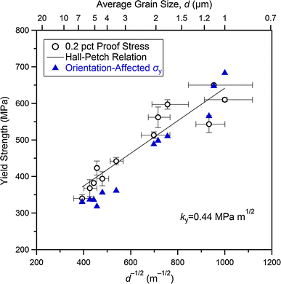
ChatGPT Data:

Orientation-Affected σ_y (Blue) d^{-1/2} (m^{-1/2}) Yield Strength (MPa)
Orientation-Affected σ_y 1.0e+6 170
Orientation-Affected σ_y 1.2e+6 195
Orientation-Affected σ_y 1.4e+6 225
Orientation-Affected σ_y 1.6e+6 255
Orientation-Affected σ_y 1.8e+6 280
Orientation-Affected σ_y 2.0e+6 305
Orientation-Affected σ_y 2.2e+6 330
Orientation-Affected σ_y 2.4e+6 355

Perplexity Data:
Orientation-Affected σ_y (Blue) | d−1/2d^{-1/2} (m−1/2^{-1/2}) | Yield Strength (MPa)
Orientation-Affected σ_y | 1.0e+6 | 170
Orientation-Affected σ_y | 1.2e+6 | 195
Orientation-Affected σ_y | 1.4e+6 | 225
Orientation-Affected σ_y | 1.6e+6 | 255
Orientation-Affected σ_y | 1.8e+6 | 280
Orientation-Affected σ_y | 2.0e+6 | 305
Orientation-Affected σ_y | 2.2e+6 | 330
Orientation-Affected σ_y | 2.4e+6 | 355

Gemini Data:
Orientation-Affected σ_y (Blue) | d−1/2d^{-1/2} (m−1/2^{-1/2}) | Yield Strength (MPa)
0.2% Proof Stress (Black) | 1.0e+6 | 150
0.2% Proof Stress (Black) | 1.2e+6 | 175
0.2% Proof Stress (Black) | 1.4e+6 | 200
0.2% Proof Stress (Black) | 1.6e+6 | 230
0.2% Proof Stress (Black) | 1.8e+6 | 255
0.2% Proof Stress (Black) | 2.0e+6 | 280
0.2% Proof Stress (Black) | 2.2e+6 | 305
0.2% Proof Stress (Black) | 2.4e+6 | 330

Figure 6:
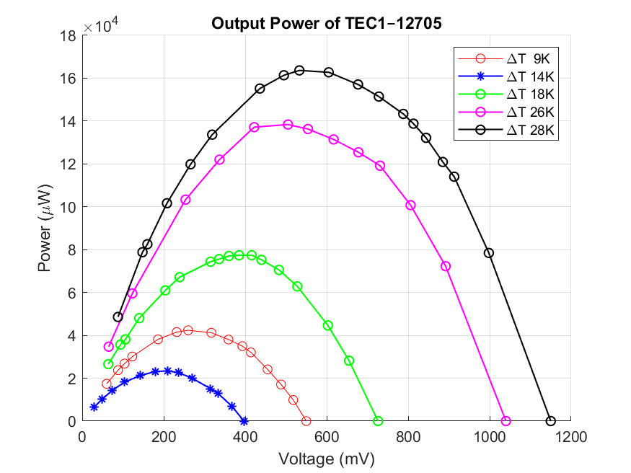
ChatGPT Data:
Dataset | Z_prime | Z_double_prime
AC | 10.00 | 0
AC | 10.79 | 2
AC | 11.58 | 4
AC | 12.37 | 6
AC | 13.16 | 8
AC | 13.95 | 10
AC | 14.74 | 12
AC | 15.53 | 15
AC | 16.32 | 18
AC | 17.11 | 21
AC | 17.89 | 25
AC | 18.68 | 28
AC | 19.47 | 31
AC | 20.26 | 35
AC | 21.05 | 38
AC | 21.84 | 40
AC | 22.63 | 42
AC | 23.42 | 45
AC | 24.21 | 47
AC | 25.00 | 50
AC750 | 10.00 | 0
AC750 | 11.58 | 1
AC750 | 13.16 | 2
AC750 | 14.74 | 4
AC750 | 16.32 | 6
AC750 | 17.89 | 8
AC750 | 19.47 | 10
AC750 | 21.05 | 13
AC750 | 22.63 | 15
AC750 | 24.21 | 18
AC750 | 25.79 | 21
AC750 | 27.37 | 24
AC750 | 28.95 | 27
AC750 | 30.53 | 30
AC750 | 32.11 | 33
AC750 | 33.68 | 37
AC750 | 35.26 | 40
AC750 | 36.84 | 43
AC750 | 38.42 | 46
AC750 | 40.00 | 49
AC800 | 10.00 | 0
AC800 | 12.11 | 1
AC800 | 14.21 | 3
AC800 | 16.32 | 5
AC800 | 18.42 | 8
AC800 | 20.53 | 12
AC800 | 22.63 | 16
AC800 | 24.74 | 20
AC800 | 26.84 | 24
AC800 | 28.95 | 28
AC800 | 31.05 | 32
AC800 | 33.16 | 36
AC800 | 35.26 | 39
AC800 | 37.37 | 42
AC800 | 39.47 | 44
AC800 | 41.58 | 46
AC800 | 43.68 | 48
AC800 | 45.79 | 49
AC800 | 47.89 | 50
AC800 | 50.00 | 50
AC850 | 10.00 | 0
AC850 | 12.37 | 1
AC850 | 14.74 | 2
AC850 | 17.11 | 3
AC850 | 19.47 | 5
AC850 | 21.84 | 8
AC850 | 24.21 | 12
AC850 | 26.58 | 16
AC850 | 28.95 | 20
AC850 | 31.32 | 24
AC850 | 33.68 | 27
AC850 | 36.05 | 30
AC850 | 38.42 | 32
AC850 | 40.79 | 35
AC850 | 43.16 | 37
AC850 | 45.53 | 39
AC850 | 47.89 | 40
AC850 | 50.26 | 41
AC850 | 52.63 | 42
AC850 | 55.00 | 43
AC900 | 10.00 | 0
AC900 | 13.42 | 2
AC900 | 16.84 | 4
AC900 | 20.26 | 6
AC900 | 23.68 | 9
AC900 | 27.11 | 13
AC900 | 30.53 | 18
AC900 | 33.95 | 22
AC900 | 37.37 | 27
AC900 | 40.79 | 32
AC900 | 44.21 | 36
AC900 | 47.63 | 39
AC900 | 51.05 | 42
AC900 | 54.47 | 44
AC900 | 57.89 | 46
AC900 | 61.32 | 48
AC900 | 64.74 | 49
AC900 | 68.16 | 50
AC900 | 71.58 | 50
AC900 | 75.00 | 50

Perplexity Data:
Dataset | Z_prime | Z_double_prime
AC | 10.00 | 0
AC | 10.79 | 3
AC | 11.58 | 5
AC | 12.37 | 7
AC | 13.16 | 9
AC | 13.95 | 11
AC | 14.74 | 13
AC | 15.53 | 15
AC | 16.32 | 17
AC | 17.11 | 19
AC | 17.89 | 21
AC | 18.68 | 22
AC | 19.47 | 23
AC | 20.26 | 24
AC | 21.05 | 25
AC | 21.84 | 25
AC | 22.63 | 25
AC | 23.42 | 25
AC | 24.21 | 25
AC | 25.00 | 25
AC750 | 10.00 | 0
AC750 | 12.11 | 2
AC750 | 14.21 | 4
AC750 | 16.32 | 6
AC750 | 18.42 | 8
AC750 | 20.53 | 10
AC750 | 22.63 | 12
AC750 | 24.74 | 14
AC750 | 26.84 | 16
AC750 | 28.95 | 18
AC750 | 31.05 | 20
AC750 | 33.16 | 22
AC750 | 35.26 | 24
AC750 | 37.37 | 26
AC750 | 39.47 | 28
AC750 | 41.58 | 30
AC750 | 43.68 | 32
AC750 | 45.79 | 34
AC750 | 47.89 | 36
AC750 | 50.00 | 38
AC800 | 10.00 | 0
AC800 | 12.63 | 2
AC800 | 15.26 | 4
AC800 | 17.89 | 7
AC800 | 20.53 | 10
AC800 | 23.16 | 13
AC800 | 25.79 | 16
AC800 | 28.42 | 19
AC800 | 31.05 | 22
AC800 | 33.68 | 25
AC800 | 36.32 | 28
AC800 | 38.95 | 31
AC800 | 41.58 | 34
AC800 | 44.21 | 37
AC800 | 46.84 | 40
AC800 | 49.47 | 43
AC800 | 52.11 | 46
AC800 | 54.74 | 48
AC800 | 57.37 | 49
AC800 | 60.00 | 50
AC850 | 10.00 | 0
AC850 | 12.89 | 1
AC850 | 15.79 | 3
AC850 | 18.68 | 5
AC850 | 21.58 | 7
AC850 | 24.47 | 9
AC850 | 27.37 | 11
AC850 | 30.26 | 13
AC850 | 33.16 | 15
AC850 | 36.05 | 17
AC850 | 38.95 | 19
AC850 | 41.84 | 21
AC850 | 44.74 | 23
AC850 | 47.63 | 25
AC850 | 50.53 | 27
AC850 | 53.42 | 29
AC850 | 56.32 | 31
AC850 | 59.21 | 33
AC850 | 62.11 | 35
AC850 | 65.00 | 37
AC900 | 10.00 | 0
AC900 | 13.95 | 3
AC900 | 17.89 | 6
AC900 | 21.84 | 9
AC900 | 25.79 | 12
AC900 | 29.74 | 15
AC900 | 33.68 | 18
AC900 | 37.63 | 21
AC900 | 41.58 | 24
AC900 | 45.53 | 27
AC900 | 49.47 | 30
AC900 | 53.42 | 33
AC900 | 57.37 | 36
AC900 | 61.32 | 39
AC900 | 65.26 | 42
AC900 | 69.21 | 45
AC900 | 73.16 | 48
AC900 | 77.11 | 51
AC900 | 81.05 | 53
AC900 | 85.00 | 55

Gemini Data:
Dataset | Z_prime | Z_double_prime
AC | 10.00 | 0
AC | 10.79 | 1
AC | 11.58 | 2
AC | 12.37 | 3
AC | 13.16 | 4
AC | 13.95 | 5
AC | 14.74 | 6
AC | 15.53 | 7
AC | 16.32 | 8
AC | 17.11 | 9
AC | 17.89 | 10
AC | 18.68 | 11
AC | 19.47 | 12
AC | 20.26 | 13
AC | 21.05 | 14
AC | 21.84 | 15
AC | 22.63 | 16
AC | 23.42 | 17
AC | 24.21 | 18
AC | 25.00 | 19
AC750 | 10.00 | 0
AC750 | 12.11 | 1
AC750 | 14.21 | 2
AC750 | 16.32 | 3
AC750 | 18.42 | 4
AC750 | 20.53 | 5
AC750 | 22.63 | 6
AC750 | 24.74 | 7
AC750 | 26.84 | 8
AC750 | 28.95 | 9
AC750 | 31.05 | 10
AC750 | 33.16 | 11
AC750 | 35.26 | 12
AC750 | 37.37 | 13
AC750 | 39.47 | 14
AC750 | 41.58 | 15
AC750 | 43.68 | 17
AC750 | 45.79 | 19
AC750 | 47.89 | 21
AC750 | 50.00 | 23
AC800 | 10.00 | 0
AC800 | 12.11 | 1
AC800 | 14.21 | 2
AC800 | 16.32 | 3
AC800 | 18.42 | 4
AC800 | 20.53 | 5
AC800 | 22.63 | 6
AC800 | 24.74 | 7
AC800 | 26.84 | 8
AC800 | 28.95 | 9
AC800 | 31.05 | 10
AC800 | 33.16 | 12
AC800 | 35.26 | 14
AC800 | 37.37 | 16
AC800 | 39.47 | 18
AC800 | 41.58 | 20
AC800 | 43.68 | 23
AC800 | 45.79 | 26
AC800 | 47.89 | 30
AC800 | 50.00 | 34
AC850 | 10.00 | 0
AC850 | 12.89 | 1
AC850 | 15.79 | 2
AC850 | 18.68 | 3
AC850 | 21.58 | 4
AC850 | 24.47 | 5
AC850 | 27.37 | 7
AC850 | 30.26 | 9
AC850 | 33.16 | 11
AC850 | 36.05 | 13
AC850 | 38.95 | 16
AC850 | 41.84 | 19
AC850 | 44.74 | 22
AC850 | 47.63 | 26
AC850 | 50.53 | 30
AC850 | 53.42 | 34
AC850 | 56.32 | 38
AC850 | 59.21 | 42
AC850 | 62.11 | 46
AC850 | 65.00 | 50
AC900 | 10.00 | 0
AC900 | 13.42 | 1
AC900 | 16.84 | 2
AC900 | 20.26 | 3
AC900 | 23.68 | 4
AC900 | 27.11 | 5
AC900 | 30.53 | 6
AC900 | 33.95 | 7
AC900 | 37.37 | 8
AC900 | 40.79 | 9
AC900 | 44.21 | 10
AC900 | 47.63 | 12
AC900 | 51.05 | 14
AC900 | 54.47 | 16
AC900 | 57.89 | 18
AC900 | 61.32 | 20
AC900 | 64.74 | 23
AC900 | 68.16 | 26
AC900 | 71.58 | 30
AC900 | 75.00 | 34

Figure 7:
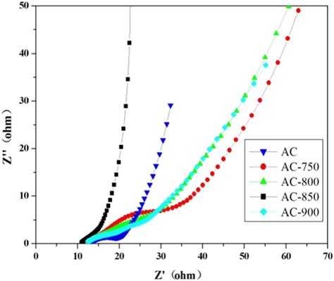
ChatGPT data:
Point Index | Z''_AC | Z''_AC_750K | Z''_AC_800K | Z''_AC_850K | Z''_AC_900K
1 | 0 | 0 | 0 | 0 | 0
2 | 2 | 1 | 1 | 1 | 2
3 | 4 | 2 | 3 | 2 | 4
4 | 6 | 4 | 5 | 3 | 6
5 | 8 | 6 | 8 | 5 | 9
6 | 10 | 8 | 12 | 8 | 13
7 | 12 | 10 | 16 | 12 | 18
8 | 15 | 13 | 20 | 16 | 22
9 | 18 | 15 | 24 | 20 | 27
10 | 21 | 18 | 28 | 24 | 32
11 | 25 | 21 | 32 | 27 | 36
12 | 28 | 24 | 36 | 30 | 39
13 | 31 | 27 | 39 | 32 | 42
14 | 35 | 30 | 42 | 35 | 44
15 | 38 | 33 | 44 | 37 | 46
16 | 40 | 37 | 46 | 39 | 48
17 | 42 | 40 | 48 | 40 | 49
18 | 45 | 43 | 49 | 41 | 50
19 | 47 | 46 | 50 | 42 | 50
20 | 50 | 49 | 50 | 43 | 50

Perplexity data:
Point Index | Z''_AC | Z''_AC_750K | Z''_AC_800K | Z''_AC_850K | Z''_AC_900K
1 | 0 | 0 | 0 | 0 | 0
2 | 3 | 2 | 2 | 1 | 3
3 | 5 | 4 | 4 | 3 | 6
4 | 7 | 6 | 7 | 5 | 9
5 | 9 | 8 | 10 | 7 | 12
6 | 11 | 10 | 13 | 9 | 15
7 | 13 | 12 | 16 | 11 | 18
8 | 15 | 14 | 19 | 13 | 21
9 | 17 | 16 | 22 | 15 | 24
10 | 19 | 18 | 25 | 17 | 27
11 | 21 | 20 | 28 | 19 | 30
12 | 22 | 22 | 31 | 21 | 33
13 | 23 | 24 | 34 | 23 | 36
14 | 24 | 26 | 37 | 25 | 39
15 | 25 | 28 | 40 | 27 | 42
16 | 25 | 30 | 43 | 29 | 45
17 | 25 | 32 | 46 | 31 | 48
18 | 25 | 34 | 48 | 33 | 51
19 | 25 | 36 | 49 | 35 | 53
20 | 25 | 38 | 50 | 37 | 55

Gemini data:
Point Index | Z''_AC | Z''_AC_750K | Z''_AC_800K | Z''_AC_850K | Z''_AC_900K
1 | 0 | 0 | 0 | 0 | 0
2 | 1 | 1 | 1 | 1 | 1
3 | 2 | 2 | 2 | 2 | 2
4 | 3 | 3 | 3 | 3 | 3
5 | 4 | 4 | 4 | 4 | 4
6 | 5 | 5 | 5 | 5 | 5
7 | 6 | 6 | 6 | 7 | 6
8 | 7 | 7 | 7 | 9 | 7
9 | 8 | 8 | 8 | 11 | 8
10 | 9 | 9 | 9 | 13 | 9
11 | 10 | 10 | 10 | 16 | 10
12 | 11 | 11 | 12 | 19 | 12
13 | 12 | 12 | 14 | 22 | 14
14 | 13 | 13 | 16 | 26 | 16
15 | 14 | 14 | 18 | 30 | 18
16 | 15 | 15 | 20 | 34 | 20
17 | 16 | 17 | 23 | 38 | 23
18 | 17 | 19 | 26 | 42 | 26
19 | 18 | 21 | 30 | 46 | 30
20 | 19 | 23 | 34 | 50 | 34

Figure 8:
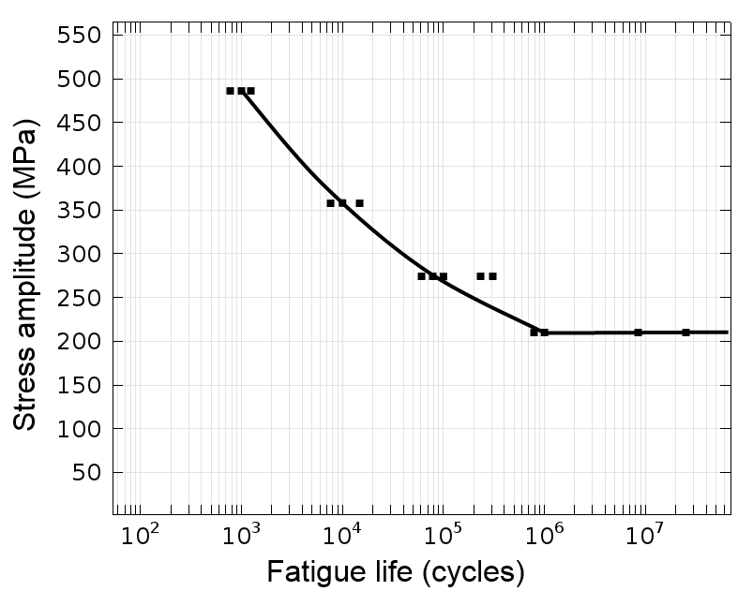
ChatGPT Data:
Dataset | Fatigue Life (cycles) | Stress Amplitude (MPa)
Data Points | 1,000 | 480
Data Points | 10,000 | 360
Data Points | 100,000 | 270
Data Points | 1,000,000 | 210
Data Points | 10,000,000 | 210

Perplexity Data:
Dataset | Fatigue Life (cycles) | Stress Amplitude (MPa)
Data Points | 100 | 500
Data Points | 1,000 | 450
Data Points | 10,000 | 350
Data Points | 100,000 | 300
Data Points | 1,000,000 | 250
Data Points | 10,000,000 | 210

Gemini Data:
Dataset | Fatigue Life (cycles) | Stress Amplitude (MPa)
Data Points | 1,000 | 488
Data Points | 2,000 | 488
Data Points | 5,000 | 360
Data Points | 10,000 | 360
Data Points | 20,000 | 355
Data Points | 50,000 | 275
Data Points | 100,000 | 275
Data Points | 200,000 | 270
Data Points | 500,000 | 210
Data Points | 1,000,000 | 210
Data Points | 2,000,000 | 210
Data Points | 5,000,000 | 210
Data Points | 10,000,000 | 210

Figure 9:
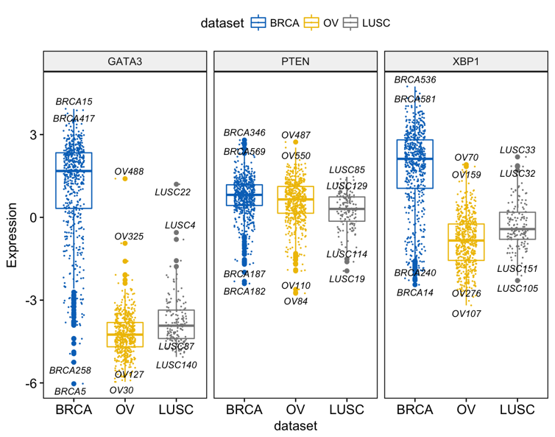
ChatGPT Data:

Gene | Dataset | Expression
GATA3 | BRCA | 1.87
GATA3 | BRCA | 0.32
GATA3 | BRCA | -2.11
GATA3 | OV | -2.45
GATA3 | OV | -3.15
GATA3 | OV | -4.01
GATA3 | LUSC | -1.75
GATA3 | LUSC | -1.98
GATA3 | LUSC | -2.21
PTEN | BRCA | 0.56
PTEN | BRCA | -0.33
PTEN | BRCA | 1.77
PTEN | OV | -1.22
PTEN | OV | -2.33
PTEN | OV | 0.25
PTEN | LUSC | -0.67
PTEN | LUSC | -0.88
PTEN | LUSC | -1.02
XBP1 | BRCA | 1.32
XBP1 | BRCA | 2.87
XBP1 | BRCA | 0.25
XBP1 | OV | 0.85
XBP1 | OV | -0.56
XBP1 | OV | 0.22
XBP1 | LUSC | -0.75
XBP1 | LUSC | -1.44
XBP1 | LUSC | 0.12

Perplexity Data:
Gene | Dataset | Expression
GATA3 | BRCA | 2.8
GATA3 | BRCA | 2.6
GATA3 | BRCA | 2.4
GATA3 | BRCA | 2.2
GATA3 | BRCA | 2.0
GATA3 | BRCA | 1.8
GATA3 | BRCA | 1.6
GATA3 | BRCA | 1.4
GATA3 | BRCA | 1.2
GATA3 | BRCA | 1.0
GATA3 | BRCA | 0.8
GATA3 | BRCA | 0.6
GATA3 | BRCA | 0.4
GATA3 | BRCA | -3.2
GATA3 | BRCA | -3.4
GATA3 | BRCA | -3.6
GATA3 | BRCA | -3.8
GATA3 | BRCA | -4.0
GATA3 | BRCA | -4.2
GATA3 | BRCA | -4.4
GATA3 | BRCA | -5.5
GATA3 | OV | 0.7
GATA3 | OV | 0.5
GATA3 | OV | -1.2
GATA3 | OV | -1.4
GATA3 | OV | -1.6
GATA3 | OV | -1.8
GATA3 | OV | -2.0
GATA3 | OV | -3.0
GATA3 | LUSC | -1.0
GATA3 | LUSC | -1.5
GATA3 | LUSC | -2.0
GATA3 | LUSC | -2.5
GATA3 | LUSC | -2.8
GATA3 | LUSC | -3.0
PTEN | BRCA | 2.0
PTEN | BRCA | 1.8
PTEN | BRCA | 1.6
PTEN | BRCA | 1.4
PTEN | BRCA | 1.2
PTEN | BRCA | 1.0
PTEN | BRCA | 0.8
PTEN | OV | 1.5
PTEN | OV | 1.3
PTEN | OV | 1.0
PTEN | OV | 0.5
PTEN | OV | 0.0
PTEN | OV | -1.0
PTEN | OV | -1.2
PTEN | OV | -1.5
PTEN | OV | -1.8
PTEN | LUSC | 2.5
PTEN | LUSC | 2.2
PTEN | LUSC | 2.0
PTEN | LUSC | 1.8
PTEN | LUSC | 1.5
PTEN | LUSC | 1.3
PTEN | LUSC | 1.0
XBP1 | BRCA | 3.0
XBP1 | BRCA | 2.8
XBP1 | BRCA | 2.6
XBP1 | BRCA | 2.4
XBP1 | BRCA | 2.2
XBP1 | BRCA | 2.0
XBP1 | BRCA | 1.8
XBP1 | BRCA | 1.6
XBP1 | OV | 1.4
XBP1 | OV | 1.0
XBP1 | OV | 0.8
XBP1 | OV | 0.6
XBP1 | OV | 0.4
XBP1 | OV | 0.2
XBP1 | OV | 0.0
XBP1 | LUSC | -0.2
XBP1 | LUSC | -0.4
XBP1 | LUSC | -0.6
XBP1 | LUSC | -0.8
XBP1 | LUSC | -1.0
XBP1 | LUSC | -1.2

Gemini Data:
Gene | Dataset | Expression
GATA3 | BRCA | 2.5
GATA3 | BRCA | 3.5
GATA3 | BRCA | 3.0
GATA3 | BRCA | 2.0
GATA3 | BRCA | 2.8
GATA3 | BRCA | 1.5
GATA3 | BRCA | 1.0
GATA3 | BRCA | -1.0
GATA3 | BRCA | -2.0
GATA3 | BRCA | -3.0
GATA3 | BRCA | -4.0
GATA3 | BRCA | -5.0
GATA3 | BRCA | -6.0
GATA3 | BRCA | -5.5
GATA3 | OV | 0.5
GATA3 | OV | -1.0
GATA3 | OV | -2.0
GATA3 | OV | -3.0
GATA3 | OV | -4.0
GATA3 | OV | -5.0
GATA3 | OV | -5.5
GATA3 | LUSC | 0.0
GATA3 | LUSC | -1.0
GATA3 | LUSC | -2.0
GATA3 | LUSC | -3.0
GATA3 | LUSC | -3.5
GATA3 | LUSC | -4.0
PTEN | BRCA | 1.5
PTEN | BRCA | 1.0
PTEN | BRCA | 0.5
PTEN | BRCA | 0.0
PTEN | BRCA | -0.5
PTEN | BRCA | -1.0
PTEN | BRCA | -1.5
PTEN | BRCA | -2.0
PTEN | BRCA | -2.5
PTEN | BRCA | -3.0
PTEN | OV | 0.5
PTEN | OV | 0.0
PTEN | OV | -0.5
PTEN | OV | -1.0
PTEN | OV | -1.5
PTEN | OV | -2.0
PTEN | OV | -2.5
PTEN | OV | -3.0
PTEN | LUSC | 0.0
PTEN | LUSC | -0.5
PTEN | LUSC | -1.0
PTEN | LUSC | -1.5
PTEN | LUSC | -2.0
PTEN | LUSC | -2.5
PTEN | LUSC | -3.0
XBP1 | BRCA | 4.0
XBP1 | BRCA | 3.5
XBP1 | BRCA | 3.0
XBP1 | BRCA | 2.5
XBP1 | BRCA | 2.0
XBP1 | BRCA | 1.5
XBP1 | BRCA | 1.0
XBP1 | BRCA | 0.5
XBP1 | BRCA | 0.0
XBP1 | BRCA | -0.5
XBP1 | BRCA | -1.0
XBP1 | BRCA | -1.5
XBP1 | BRCA | -2.0
XBP1 | OV | 1.0
XBP1 | OV | 0.5
XBP1 | OV | 0.0
XBP1 | OV | -0.5
XBP1 | OV | -1.0
XBP1 | OV | -1.5
XBP1 | OV | -2.0
XBP1 | OV | -2.5
XBP1 | OV | -3.0
XBP1 | LUSC | 0.0
XBP1 | LUSC | -0.5
XBP1 | LUSC | -1.0
XBP1 | LUSC | -1.5
XBP1 | LUSC | -2.0
XBP1 | LUSC | -2.5
XBP1 | LUSC | -3.0

Figure 11:
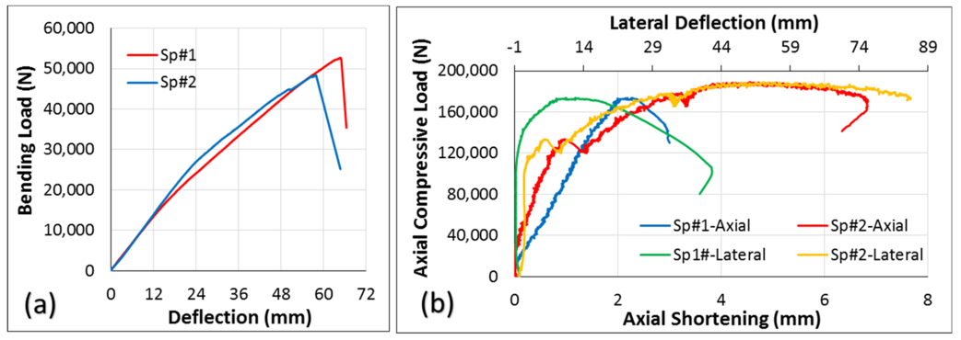

ChatGPT Data:
Label | X-axis (mm) | Y-axis (N)
Bending Load Sp#1 (Red) | 0.00 | 0.00
Bending Load Sp#1 (Red) | 8.00 | 10310.44
Bending Load Sp#1 (Red) | 16.00 | 18394.42
Bending Load Sp#1 (Red) | 24.00 | 25210.74
Bending Load Sp#1 (Red) | 32.00 | 31157.29
Bending Load Sp#1 (Red) | 40.00 | 36443.94
Bending Load Sp#1 (Red) | 48.00 | 41242.98
Bending Load Sp#1 (Red) | 56.00 | 45629.46
Bending Load Sp#1 (Red) | 64.00 | 49662.12
Bending Load Sp#1 (Red) | 72.00 | 53400.00
Bending Load Sp#2 (Blue) | 0.00 | 0.00
Bending Load Sp#2 (Blue) | 8.00 | 9966.79
Bending Load Sp#2 (Blue) | 16.00 | 17864.12
Bending Load Sp#2 (Blue) | 24.00 | 24614.67
Bending Load Sp#2 (Blue) | 32.00 | 30688.89
Bending Load Sp#2 (Blue) | 40.00 | 36195.84
Bending Load Sp#2 (Blue) | 48.00 | 41231.15
Bending Load Sp#2 (Blue) | 56.00 | 45815.21
Bending Load Sp#2 (Blue) | 64.00 | 50071.33
Bending Load Sp#2 (Blue) | 72.00 | 54000.00
Axial Load Sp#1 (Blue) | 0.00 | 0.00
Axial Load Sp#1 (Blue) | 0.89 | 76231.74
Axial Load Sp#1 (Blue) | 1.78 | 123438.15
Axial Load Sp#1 (Blue) | 2.67 | 153102.33
Axial Load Sp#1 (Blue) | 3.56 | 172089.34
Axial Load Sp#1 (Blue) | 4.44 | 184058.91
Axial Load Sp#1 (Blue) | 5.33 | 191552.29
Axial Load Sp#1 (Blue) | 6.22 | 196173.70
Axial Load Sp#1 (Blue) | 7.11 | 198914.09
Axial Load Sp#1 (Blue) | 8.00 | 200575.19
Axial Load Sp#2 (Red) | 0.00 | 0.00
Axial Load Sp#2 (Red) | 0.89 | 69555.39
Axial Load Sp#2 (Red) | 1.78 | 113596.37
Axial Load Sp#2 (Red) | 2.67 | 142658.22
Axial Load Sp#2 (Red) | 3.56 | 161084.66
Axial Load Sp#2 (Red) | 4.44 | 173162.61
Axial Load Sp#2 (Red) | 5.33 | 181265.04
Axial Load Sp#2 (Red) | 6.22 | 186394.18
Axial Load Sp#2 (Red) | 7.11 | 189163.53
Axial Load Sp#2 (Red) | 8.00 | 190763.96
Lateral Defl. Sp#1 (Green) | 0.00 | 0.00
Lateral Defl. Sp#1 (Green) | 0.89 | 15550.10
Lateral Defl. Sp#1 (Green) | 1.78 | 27696.98
Lateral Defl. Sp#1 (Green) | 2.67 | 35906.69
Lateral Defl. Sp#1 (Green) | 3.56 | 39596.78
Lateral Defl. Sp#1 (Green) | 4.44 | 38476.04
Lateral Defl. Sp#1 (Green) | 5.33 | 32668.97
Lateral Defl. Sp#1 (Green) | 6.22 | 22691.71
Lateral Defl. Sp#1 (Green) | 7.11 | 9432.10
Lateral Defl. Sp#1 (Green) | 8.00 | -4763.36
Lateral Defl. Sp#2 (Yellow) | 0.00 | 0.00
Lateral Defl. Sp#2 (Yellow) | 0.89 | 17910.18
Lateral Defl. Sp#2 (Yellow) | 1.78 | 31318.29
Lateral Defl. Sp#2 (Yellow) | 2.67 | 39509.45
Lateral Defl. Sp#2 (Yellow) | 3.56 | 42676.81
Lateral Defl. Sp#2 (Yellow) | 4.44 | 40272.11
Lateral Defl. Sp#2 (Yellow) | 5.33 | 32444.76
Lateral Defl. Sp#2 (Yellow) | 6.22 | 20035.96
Lateral Defl. Sp#2 (Yellow) | 7.11 | 5228.15
Lateral Defl. Sp#2 (Yellow) | 8.00 | -10380.73

Perplexity Data:
Label | X-axis (mm) | Y-axis (N)
Bending Load Sp#1 (Red) | 0.00 | 0.00
Bending Load Sp#1 (Red) | 8.00 | 9763.84
Bending Load Sp#1 (Red) | 16.00 | 16526.39
Bending Load Sp#1 (Red) | 24.00 | 22378.14
Bending Load Sp#1 (Red) | 32.00 | 27560.69
Bending Load Sp#1 (Red) | 40.00 | 32216.93
Bending Load Sp#1 (Red) | 48.00 | 36440.14
Bending Load Sp#1 (Red) | 56.00 | 40300.36
Bending Load Sp#1 (Red) | 64.00 | 43842.64
Bending Load Sp#1 (Red) | 72.00 | 47132.52
Bending Load Sp#2 (Blue) | 0.00 | 0.00
Bending Load Sp#2 (Blue) | 8.00 | 9250.13
Bending Load Sp#2 (Blue) | 16.00 | 15429.63
Bending Load Sp#2 (Blue) | 24.00 | 20944.47
Bending Load Sp#2 (Blue) | 32.00 | 25922.01
Bending Load Sp#2 (Blue) | 40.00 | 30473.80
Bending Load Sp#2 (Blue) | 48.00 | 34679.53
Bending Load Sp#2 (Blue) | 56.00 | 38596.93
Bending Load Sp#2 (Blue) | 64.00 | 42263.92
Bending Load Sp#2 (Blue) | 72.00 | 45708.84
Axial Load Sp#1 (Blue) | 0.00 | 0.00
Axial Load Sp#1 (Blue) | 0.89 | 73726.32
Axial Load Sp#1 (Blue) | 1.78 | 120937.80
Axial Load Sp#1 (Blue) | 2.67 | 150876.86
Axial Load Sp#1 (Blue) | 3.56 | 170308.00
Axial Load Sp#1 (Blue) | 4.44 | 182676.13
Axial Load Sp#1 (Blue) | 5.33 | 190438.16
Axial Load Sp#1 (Blue) | 6.22 | 195197.93
Axial Load Sp#1 (Blue) | 7.11 | 198011.53
Axial Load Sp#1 (Blue) | 8.00 | 199647.27
Axial Load Sp#2 (Red) | 0.00 | 0.00
Axial Load Sp#2 (Red) | 0.89 | 64184.61
Axial Load Sp#2 (Red) | 1.78 | 108173.32
Axial Load Sp#2 (Red) | 2.67 | 138539.08
Axial Load Sp#2 (Red) | 3.56 | 158188.12
Axial Load Sp#2 (Red) | 4.44 | 170276.25
Axial Load Sp#2 (Red) | 5.33 | 178202.37
Axial Load Sp#2 (Red) | 6.22 | 183127.59
Axial Load Sp#2 (Red) | 7.11 | 186188.83
Axial Load Sp#2 (Red) | 8.00 | 188086.77
Lateral Defl. Sp#1 (Green) | 0.00 | 0.00
Lateral Defl. Sp#1 (Green) | 0.89 | 13750.49
Lateral Defl. Sp#1 (Green) | 1.78 | 25313.81
Lateral Defl. Sp#1 (Green) | 2.67 | 33918.37
Lateral Defl. Sp#1 (Green) | 3.56 | 39247.75
Lateral Defl. Sp#1 (Green) | 4.44 | 41045.27
Lateral Defl. Sp#1 (Green) | 5.33 | 39233.65
Lateral Defl. Sp#1 (Green) | 6.22 | 33978.73
Lateral Defl. Sp#1 (Green) | 7.11 | 25635.55
Lateral Defl. Sp#1 (Green) | 8.00 | 14736.07
Lateral Defl. Sp#2 (Yellow) | 0.00 | 0.00
Lateral Defl. Sp#2 (Yellow) | 0.89 | 15249.56
Lateral Defl. Sp#2 (Yellow) | 1.78 | 27957.92
Lateral Defl. Sp#2 (Yellow) | 2.67 | 37094.60
Lateral Defl. Sp#2 (Yellow) | 3.56 | 42020.23
Lateral Defl. Sp#2 (Yellow) | 4.44 | 42467.60
Lateral Defl. Sp#2 (Yellow) | 5.33 | 38569.84
Lateral Defl. Sp#2 (Yellow) | 6.22 | 30812.92
Lateral Defl. Sp#2 (Yellow) | 7.11 | 19933.50
Lateral Defl. Sp#2 (Yellow) | 8.00 | 6912.21

Gemini Data:
Label | X-axis (mm) | Y-axis (N)
Bending Load Sp#1 (Red) | 0 | 0
Bending Load Sp#1 (Red) | 6 | 5000
Bending Load Sp#1 (Red) | 12 | 10000
Bending Load Sp#1 (Red) | 18 | 15000
Bending Load Sp#1 (Red) | 24 | 20000
Bending Load Sp#1 (Red) | 30 | 25000
Bending Load Sp#1 (Red) | 36 | 30000
Bending Load Sp#1 (Red) | 42 | 35000
Bending Load Sp#1 (Red) | 48 | 40000
Bending Load Sp#1 (Red) | 54 | 45000
Bending Load Sp#1 (Red) | 60 | 50000
Bending Load Sp#1 (Red) | 66 | 52000
Bending Load Sp#1 (Red) | 72 | 52000
Bending Load Sp#2 (Blue) | 0 | 0
Bending Load Sp#2 (Blue) | 6 | 5000
Bending Load Sp#2 (Blue) | 12 | 10000
Bending Load Sp#2 (Blue) | 18 | 15000
Bending Load Sp#2 (Blue) | 24 | 20000
Bending Load Sp#2 (Blue) | 30 | 25000
Bending Load Sp#2 (Blue) | 36 | 30000
Bending Load Sp#2 (Blue) | 42 | 35000
Bending Load Sp#2 (Blue) | 48 | 40000
Bending Load Sp#2 (Blue) | 54 | 45000
Bending Load Sp#2 (Blue) | 60 | 50000
Bending Load Sp#2 (Blue) | 66 | 51000
Bending Load Sp#2 (Blue) | 72 | 25000
Axial Load Sp#1 Axial (Blue) | 0 | 0
Axial Load Sp#1 Axial (Blue) | 0.5 | 20000
Axial Load Sp#1 Axial (Blue) | 1 | 40000
Axial Load Sp#1 Axial (Blue) | 1.5 | 60000
Axial Load Sp#1 Axial (Blue) | 2 | 80000
Axial Load Sp#1 Axial (Blue) | 2.5 | 100000
Axial Load Sp#1 Axial (Blue) | 3 | 120000
Axial Load Sp#1 Axial (Blue) | 3.5 | 140000
Axial Load Sp#1 Axial (Blue) | 4 | 160000
Axial Load Sp#1 Axial (Blue) | 4.5 | 170000
Axial Load Sp#1 Axial (Blue) | 5 | 175000
Axial Load Sp#2 Axial (Red) | 0 | 0
Axial Load Sp#2 Axial (Red) | 0.5 | 20000
Axial Load Sp#2 Axial (Red) | 1 | 40000
Axial Load Sp#2 Axial (Red) | 1.5 | 60000
Axial Load Sp#2 Axial (Red) | 2 | 80000
Axial Load Sp#2 Axial (Red) | 2.5 | 100000
Axial Load Sp#2 Axial (Red) | 3 | 120000
Axial Load Sp#2 Axial (Red) | 3.5 | 140000
Axial Load Sp#2 Axial (Red) | 4 | 160000
Axial Load Sp#2 Axial (Red) | 4.5 | 170000
Axial Load Sp#2 Axial (Red) | 5 | 180000
Axial Load Sp#2 Axial (Red) | 5.5 | 185000
Axial Load Sp#2 Axial (Red) | 6 | 160000
Axial Load Sp#1 Lateral (Green) | 0 | 0
Axial Load Sp#1 Lateral (Green) | 0.5 | 20000
Axial Load Sp#1 Lateral (Green) | 1 | 50000
Axial Load Sp#1 Lateral (Green) | 1.5 | 100000
Axial Load Sp#1 Lateral (Green) | 2 | 150000
Axial Load Sp#1 Lateral (Green) | 2.5 | 180000
Axial Load Sp#1 Lateral (Green) | 3 | 180000
Axial Load Sp#1 Lateral (Green) | 3.5 | 170000
Axial Load Sp#1 Lateral (Green) | 4 | 140000
Axial Load Sp#2 Lateral (Yellow) | 0 | 0
Axial Load Sp#2 Lateral (Yellow) | 0.5 | 20000
Axial Load Sp#2 Lateral (Yellow) | 1 | 40000
Axial Load Sp#2 Lateral (Yellow) | 1.5 | 60000
Axial Load Sp#2 Lateral (Yellow) | 2 | 80000
Axial Load Sp#2 Lateral (Yellow) | 2.5 | 100000
Axial Load Sp#2 Lateral (Yellow) | 3 | 120000
Axial Load Sp#2 Lateral (Yellow) | 3.5 | 140000
Axial Load Sp#2 Lateral (Yellow) | 4 | 160000
Axial Load Sp#2 Lateral (Yellow) | 4.5 | 170000
Axial Load Sp#2 Lateral (Yellow) | 5 | 180000
Axial Load Sp#2 Lateral (Yellow) | 5.5 | 185000
Axial Load Sp#2 Lateral (Yellow) | 6 | 185000
Axial Load Sp#2 Lateral (Yellow) | 6.5 | 180000
Axial Load Sp#2 Lateral (Yellow) | 7 | 175000
Axial Load Sp#2 Lateral (Yellow) | 7.5 | 170000
Axial Load Sp#2 Lateral (Yellow) | 8 | 160000

Figure 12:
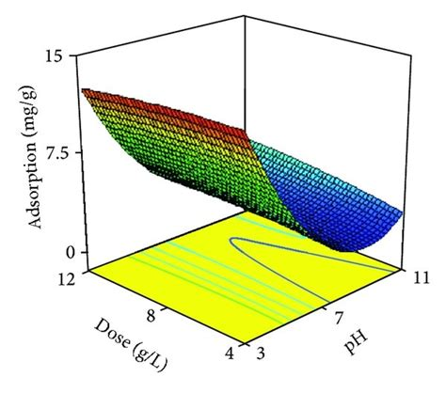
ChatGPT Data:
pH Dose Adsorption
3.0 1.0 0.5945
3.0 2.379 1.810
3.0 3.758 4.625
3.0 5.138 7.040
3.0 6.517 9.906
3.0 7.896 11.810
3.0 9.276 12.480
3.0 10.655 12.190
3.0 12.034 10.970

5.0 1.0 1.492
5.0 2.379 4.544
5.0 3.758 8.099
5.0 5.138 11.10
5.0 6.517 13.01
5.0 7.896 13.58
5.0 9.276 12.82
5.0 10.655 10.74
5.0 12.034 7.660

7.0 1.0 3.190
7.0 2.379 7.474
7.0 3.758 11.34
7.0 5.138 13.90
7.0 6.517 14.91
7.0 7.896 14.37
7.0 9.276 12.39
7.0 10.655 8.870
7.0 12.034 5.350

9.0 1.0 1.984
9.0 2.379 4.444
9.0 3.758 6.886
9.0 5.138 8.501
9.0 6.517 9.157
9.0 7.896 8.793
9.0 9.276 7.493
9.0 10.655 5.328
9.0 12.034 2.560

11.0 1.0 0.526
11.0 2.379 1.086
11.0 3.758 1.770
11.0 5.138 2.486
11.0 6.517 3.208
11.0 7.896 3.900
11.0 9.276 4.520
11.0 10.655 4.997
11.0 12.034 5.252

Perplexity Data:
pH Dose Adsorption
3.0 1.0 0.059
3.0 3.3 0.404
3.0 5.6 0.896
3.0 7.9 1.234
3.0 10.2 1.016
3.0 12.0 0.567

5.0 1.0 1.230
5.0 3.3 8.401
5.0 5.6 13.223
5.0 7.9 12.505
5.0 10.2 8.348
5.0 12.0 3.832

7.0 1.0 4.552
7.0 3.3 14.134
7.0 5.6 15.000
7.0 7.9 13.998
7.0 10.2 9.769
7.0 12.0 4.490

9.0 1.0 1.230
9.0 3.3 8.401
9.0 5.6 13.223
9.0 7.9 12.505
9.0 10.2 8.348
9.0 12.0 3.832

11.0 1.0 0.059
11.0 3.3 0.404
11.0 5.6 0.896
11.0 7.9 1.234
11.0 10.2 1.016
11.0 12.0 0.567

Gemini Data:
pH Dose Adsorption
3.0 1.0 0.055
3.0 3.3 0.407
3.0 5.6 0.941
3.0 7.9 1.251
3.0 10.2 1.019
3.0 12.0 0.560

5.0 1.0 1.256
5.0 3.3 8.109
5.0 5.6 13.299
5.0 7.9 12.435
5.0 10.2 8.068
5.0 12.0 3.787

7.0 1.0 4.371
7.0 3.3 14.244
7.0 5.6 15.000
7.0 7.9 13.559
7.0 10.2 9.340
7.0 12.0 4.373

9.0 1.0 1.256
9.0 3.3 8.109
9.0 5.6 13.299
9.0 7.9 12.435
9.0 10.2 8.068
9.0 12.0 3.787

11.0 1.0 0.055
11.0 3.3 0.407
11.0 5.6 0.941
11.0 7.9 1.251
11.0 10.2 1.019
11.0 12.0 0.560

Figure 13:
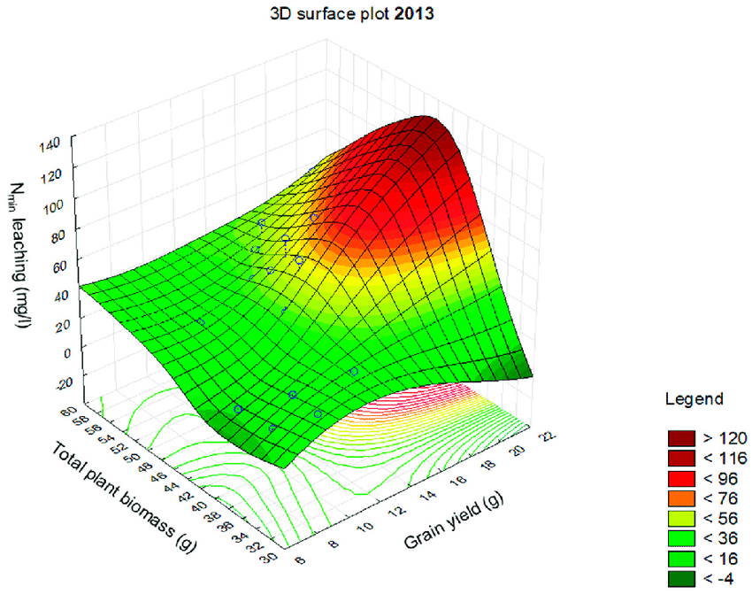
ChatGPT Data:
Grain_yield Biomass N_min_leaching
0.0 0.0 0.064
0.0 20.0 6.295
0.0 40.0 25.253
0.0 60.0 6.295
0.0 80.0 0.064

7.0 0.0 0.236
7.0 20.0 23.185
7.0 40.0 93.083
7.0 60.0 23.185
7.0 80.0 0.236

14.0 0.0 0.021
14.0 20.0 2.022
14.0 40.0 8.118
14.0 60.0 2.022
14.0 80.0 0.021

21.0 0.0 0.001
21.0 20.0 0.108
21.0 40.0 0.434
21.0 60.0 0.108
21.0 80.0 0.001

Perplexity Data:
Grain_yield Biomass N_min_leaching
4.00 25.00 0.86
4.00 35.88 9.27
4.00 46.76 32.56
4.00 57.65 38.25
4.00 68.53 18.33
4.00 79.41 2.53

8.90 25.00 0.64
8.90 35.88 11.96
8.90 46.76 52.16
8.90 57.65 61.27
8.90 68.53 30.38
8.90 79.41 4.19

13.80 25.00 0.01
13.80 35.88 5.11
13.80 46.76 140.00
13.80 57.65 114.98
13.80 68.53 53.29
13.80 79.41 7.14

18.69 25.00 0.00
18.69 35.88 0.39
18.69 46.76 49.34
18.69 57.65 40.55
18.69 68.53 16.71
18.69 79.41 2.24

22.00 25.00 0.00
22.00 35.88 0.00
22.00 46.76 8.40
22.00 57.65 5.62
22.00 68.53 2.23
22.00 79.41 0.30

Gemini Data:
Grain_Yield Biomass Nmin_Leaching
8.00 0.00 28.57
8.00 7.89 41.18
8.00 15.79 10.52
8.00 23.68 -20.00
8.00 30.00 -3.79

13.69 0.00 85.96
13.69 7.89 123.49
13.69 15.79 91.27
13.69 23.68 35.29
13.69 30.00 4.91

15.00 0.00 92.68
15.00 7.89 134.53
15.00 15.79 105.56
15.00 23.68 53.16
15.00 30.00 16.99

16.31 0.00 85.61
16.31 7.89 123.09
16.31 15.79 91.32
16.31 23.68 35.82
16.31 30.00 5.47

22.00 0.00 16.97
22.00 7.89 26.15
22.00 15.79 6.94
22.00 23.68 -12.42
22.00 30.00 -4.11

Figure 15:
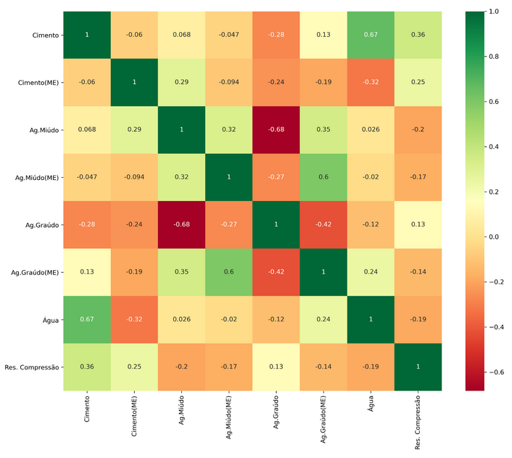
ChatGPT Data:
 | Cimento | Cimento(ME) | Ag.Múdo | Ag.Múdo(ME) | Ag.Graúdo | Ag.Graúdo(ME) | Água | Res. Compressão
Cimento | 1 | -0.06 | 0.068 | -0.047 | -0.28 | 0.13 | 0.67 | 0.36
Cimento(ME) | -0.06 | 1 | 0.29 | -0.094 | -0.24 | -0.19 | -0.32 | 0.25
Ag.Múdo | 0.068 | 0.29 | 1 | 0.32 | -0.68 | 0.35 | 0.026 | -0.2
Ag.Múdo(ME) | -0.047 | -0.094 | 0.32 | 1 | -0.27 | 0.6 | -0.02 | -0.17
Ag.Graúdo | -0.28 | -0.24 | -0.68 | -0.27 | 1 | -0.42 | -0.12 | 0.13
Ag.Graúdo(ME) | 0.13 | -0.19 | 0.35 | 0.6 | -0.42 | 1 | 0.24 | -0.14
Água | 0.67 | -0.32 | 0.026 | -0.02 | -0.12 | 0.24 | 1 | -0.19
Res.Compressão | 0.36 | 0.25 | -0.2 | -0.17 | 0.13 | -0.14 | -0.19 | 1

Perplexity Data:
 | Cimento | Cimento(ME) | Ag.Miúdo | Ag.Miúdo(ME) | Ag.Graúdo | Ag.Graúdo(ME) | Água | Res.Compressão
Cimento | 1 | -0.06 | 0.068 | -0.047 | -0.28 | 0.13 | 0.67 | 0.36
Cimento(ME) | -0.06 | 1 | 0.29 | -0.094 | -0.24 | -0.19 | -0.32 | 0.25
Ag.Miúdo | 0.068 | 0.29 | 1 | 0.32 | -0.68 | 0.35 | 0.026 | -0.2
Ag.Miúdo(ME) | -0.047 | -0.094 | 0.32 | 1 | -0.27 | 0.6 | -0.02 | -0.17
Ag.Graúdo | -0.28 | -0.24 | -0.68 | -0.27 | 1 | -0.42 | -0.12 | 0.13
Ag.Graúdo(ME) | 0.13 | -0.19 | 0.35 | 0.6 | -0.42 | 1 | 0.24 | -0.14
Água | 0.67 | -0.32 | 0.026 | -0.02 | -0.12 | 0.24 | 1 | -0.19
Res.Compressão | 0.36 | 0.25 | -0.2 | -0.17 | 0.13 | -0.14 | -0.19 | 1

Gemini Data:

 | Cimento | Cimento(ME) | Ag.Miúdo | Ag.Miúdo(ME) | Ag.Graúdo | Ag.Graúdo(ME) | Agua | Res.Compressão
Cimento | 1 | -0.06 | 0.068 | -0.047 | -0.28 | 0.13 | 0.67 | 0.36
Cimento(ME) | -0.06 | 1 | 0.29 | -0.094 | -0.24 | -0.19 | -0.32 | 0.25
Ag.Miúdo | 0.068 | 0.29 | 1 | 0.32 | -0.68 | 0.35 | 0.026 | -0.2
Ag.Miúdo(ME) | -0.047 | -0.094 | 0.32 | 1 | -0.27 | 0.6 | -0.02 | -0.17
Ag.Graúdo | -0.28 | -0.24 | -0.68 | -0.27 | 1 | -0.42 | -0.12 | 0.13
Ag.Graúdo(ME) | 0.13 | -0.19 | 0.35 | 0.6 | -0.42 | 1 | 0.24 | -0.14
Agua | 0.67 | -0.32 | 0.026 | -0.02 | -0.12 | 0.24 | 1 | -0.19
Res.Compressão | 0.36 | 0.25 | -0.2 | -0.17 | 0.13 | -0.14 | -0.19 | 1

Figure 16:
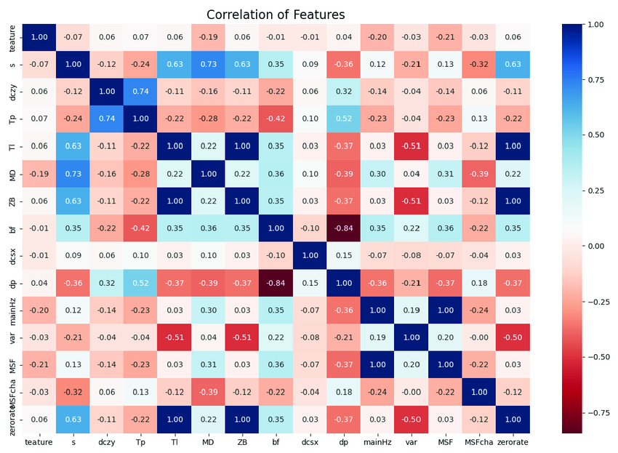
ChatGPT Data:
 | S | dzy | Tp | Tl | MD | ZB | bf | dcsx | dp | maintainZ | var | MSF | MSFficha | zerorate
S | 1 | 0.12 | 0.63 | 0.74 | 0.22 | 0.1 | 0.06 | 0.09 | 0.06 | 0.63 | 0.11 | 0.12 | -0.12 | 0.06
dzy | 0.12 | 1 | 0.74 | 0.12 | 0.19 | 0.06 | 0.03 | 0.06 | 0.02 | 0.12 | 0.1 | 0.14 | -0.03 | 0.63
Tp | 0.63 | 0.74 | 1 | 0.22 | 0.1 | 0.22 | 0.13 | 0.1 | 0.52 | 0.63 | 0.2 | 0.14 | -0.21 | -0.22
Tl | 0.74 | 0.12 | 0.22 | 1 | 0.22 | 0.35 | 0.22 | 0.1 | 0.37 | 0.12 | 0.19 | 0.13 | -0.37 | 1
MD | 0.22 | 0.19 | 0.1 | 0.22 | 1 | 0.1 | 0.1 | 0.03 | 0.3 | 0.22 | 0.22 | 0.13 | -0.08 | 0.22
ZB | 0.1 | 0.06 | 0.22 | 0.35 | 0.1 | 1 | 0.06 | 0.1 | 0.22 | 0.06 | 0.13 | 0.19 | -0.08 | 0.1
bf | 0.06 | 0.03 | 0.13 | 0.22 | 0.1 | 0.06 | 1 | 0.84 | 0.51 | 0.22 | 0.1 | 0.19 | -0.5 | 0.13
dcsx | 0.09 | 0.06 | 0.1 | 0.1 | 0.03 | 0.1 | 0.84 | 1 | 0.37 | 0.1 | 0.1 | 0.19 | -0.37 | 0.1
dp | 0.06 | 0.02 | 0.52 | 0.37 | 0.3 | 0.22 | 0.51 | 0.37 | 1 | 0.22 | 0.19 | 0.13 | -0.37 | 0.22
maintainZ | 0.63 | 0.12 | 0.63 | 0.12 | 0.22 | 0.06 | 0.22 | 0.1 | 0.22 | 1 | 0.19 | 0.13 | -0.5 | 0.12
var | 0.11 | 0.1 | 0.2 | 0.19 | 0.22 | 0.13 | 0.1 | 0.1 | 0.19 | 0.19 | 1 | 0.22 | -0.12 | -0.12
MSF | 0.12 | 0.14 | 0.14 | 0.13 | 0.13 | 0.19 | 0.19 | 0.19 | 0.13 | 0.13 | 0.22 | 1 | -0.12 | 0.12
MSFficha | -0.12 | -0.03 | -0.21 | -0.37 | -0.08 | -0.08 | -0.5 | -0.37 | -0.37 | -0.5 | -0.12 | -0.12 | 1 | -0.12
zerorate | 0.06 | 0.63 | -0.22 | 1 | 0.22 | 0.1 | 0.13 | 0.1 | 0.22 | 0.12 | -0.12 | 0.12 | -0.12 | 1

Perplexity Data:
 | S | dzy | Tp | Tl | MD | ZB | bf | dcsx | dp | maintainZ | var | MSF | MSFficha | zerorate
S | 1 | 0.12 | 0.63 | 0.74 | 0.22 | 0.1 | 0.06 | 0.09 | 0.06 | 0.63 | 0.11 | 0.12 | -0.12 | 0.06
dzy | 0.12 | 1 | 0.74 | 0.12 | 0.19 | 0.06 | 0.03 | 0.06 | 0.02 | 0.12 | 0.1 | 0.14 | -0.03 | 0.63
Tp | 0.63 | 0.74 | 1 | 0.22 | 0.1 | 0.22 | 0.13 | 0.1 | 0.52 | 0.63 | 0.2 | 0.14 | -0.21 | -0.22
Tl | 0.74 | 0.12 | 0.22 | 1 | 0.22 | 0.35 | 0.22 | 0.1 | 0.37 | 0.12 | 0.19 | 0.13 | -0.37 | 1
MD | 0.22 | 0.19 | 0.1 | 0.22 | 1 | 0.1 | 0.1 | 0.03 | 0.3 | 0.22 | 0.22 | 0.13 | -0.08 | 0.22
ZB | 0.1 | 0.06 | 0.22 | 0.35 | 0.1 | 1 | 0.06 | 0.1 | 0.22 | 0.06 | 0.13 | 0.19 | -0.08 | 0.1
bf | 0.06 | 0.03 | 0.13 | 0.22 | 0.1 | 0.06 | 1 | 0.84 | 0.51 | 0.22 | 0.1 | 0.19 | -0.5 | 0.13
dcsx | 0.09 | 0.06 | 0.1 | 0.1 | 0.03 | 0.1 | 0.84 | 1 | 0.37 | 0.1 | 0.1 | 0.19 | -0.37 | 0.1
dp | 0.06 | 0.02 | 0.52 | 0.37 | 0.3 | 0.22 | 0.51 | 0.37 | 1 | 0.22 | 0.19 | 0.13 | -0.37 | 0.22
maintainZ | 0.63 | 0.12 | 0.63 | 0.12 | 0.22 | 0.06 | 0.22 | 0.1 | 0.22 | 1 | 0.19 | 0.13 | -0.5 | 0.12
var | 0.11 | 0.1 | 0.2 | 0.19 | 0.22 | 0.13 | 0.1 | 0.1 | 0.19 | 0.19 | 1 | 0.22 | -0.12 | -0.12
MSF | 0.12 | 0.14 | 0.14 | 0.13 | 0.13 | 0.19 | 0.19 | 0.19 | 0.13 | 0.13 | 0.22 | 1 | -0.12 | 0.12
MSFficha | -0.12 | -0.03 | -0.21 | -0.37 | -0.08 | -0.08 | -0.5 | -0.37 | -0.37 | -0.5 | -0.12 | -0.12 | 1 | -0.12
zerorate | 0.06 | 0.63 | -0.22 | 1 | 0.22 | 0.1 | 0.13 | 0.1 | 0.22 | 0.12 | -0.12 | 0.12 | -0.12 | 1

Gemini Data:
 | S | dzy | Tp | Tl | MD | ZB | bf | dcsx | dp | maintainZ | var | MSF | MSFficha | zerorate
S | 1.0 | 0.120 | 0.630 | 0.740 | 0.220 | 0.10 | 0.06 | 0.09 | 0.06 | 0.63 | 0.11 | 0.12 | -0.12 | 0.06
dzy | 0.12 | 1 | 0.74 | 0.12 | 0.19 | 0.06 | 0.03 | 0.06 | 0.02 | 0.12 | 0.1 | 0.14 | -0.03 | 0.63
Tp | 0.63 | 0.74 | 1 | 0.22 | 0.10 | 0.22 | 0.13 | 0.1 | 0.52 | 0.63 | 0.2 | 0.14 | -0.21 | -0.22
Tl | 0.74 | 0.12 | 0.22 | 1 | 0.22 | 0.35 | 0.22 | 0.1 | 0.37 | 0.12 | 0.19 | 0.13 | -0.37 | 1
MD | 0.22 | 0.19 | 0.1 | 0.22 | 1 | 0.1 | 0.1 | 0.03 | 0.3 | 0.22 | 0.22 | 0.13 | -0.08 | 0.22
ZB | 0.1 | 0.06 | 0.22 | 0.35 | 0.1 | 1 | 0.06 | 0.1 | 0.22 | 0.06 | 0.13 | 0.19 | -0.08 | 0.1
bf | 0.06 | 0.03 | 0.13 | 0.22 | 0.1 | 0.06 | 1 | 0.84 | 0.51 | 0.22 | 0.1 | 0.19 | -0.5 | 0.13
dcsx | 0.09 | 0.06 | 0.1 | 0.1 | 0.03 | 0.1 | 0.84 | 1 | 0.37 | 0.1 | 0.1 | 0.19 | -0.37 | 0.1
dp | 0.06 | 0.02 | 0.52 | 0.37 | 0.3 | 0.22 | 0.51 | 0.37 | 1 | 0.22 | 0.19 | 0.13 | -0.37 | 0.22
maintainZ | 0.63 | 0.12 | 0.63 | 0.12 | 0.22 | 0.06 | 0.22 | 0.1 | 0.22 | 1 | 0.19 | 0.13 | -0.5 | 0.12
var | 0.11 | 0.1 | 0.2 | 0.19 | 0.22 | 0.13 | 0.1 | 0.1 | 0.19 | 0.19 | 1 | 0.22 | -0.12 | -0.12
MSF | 0.12 | 0.14 | 0.14 | 0.13 | 0.13 | 0.190 | 0.19 | 0.19 | 0.13 | 0.13 | 0.22 | 1 | -0.12 | 0.12
MSFficha | -0.12 | -0.03 | -0.21 | -0.37 | -0.08 | -0.08 | -0.5 | -0.37 | -0.37 | -0.5 | -0.12 | -0.12 | 1 | -0.12
zerorate | 0.06 | 0.63 | -0.220 | 1 | 0.220 | 0.10 | 0.13 | 0.1 | 0.22 | 0.12 | -0.12 | 0.12 | -0.12 | 1

Figure 17:
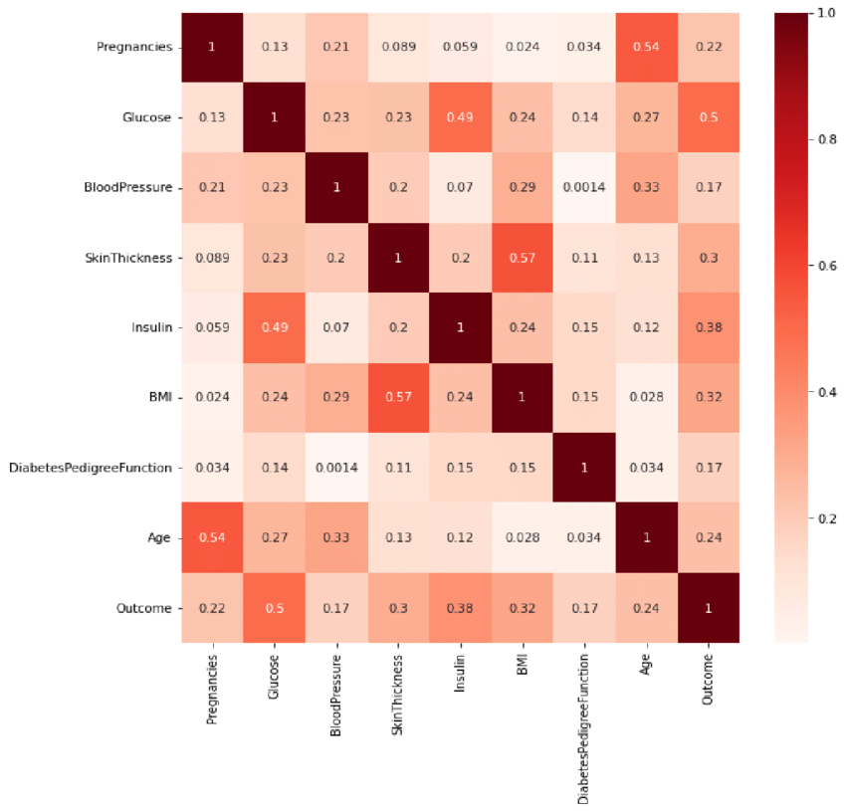
ChatGPT Data:
 | Pregnancies | Glucose | BloodPressure | SkinThickness | Insulin | BMI | DiabetesPedigreeFunction | Age | Outcome
Pregnancies | 1 | 0.13 | 0.21 | 0.089 | 0.059 | 0.024 | 0.034 | 0.54 | 0.22
Glucose | 0.13 | 1 | 0.23 | 0.23 | 0.49 | 0.24 | 0.14 | 0.27 | 0.5
BloodPressure | 0.21 | 0.23 | 1 | 0.2 | 0.07 | 0.29 | 0.0014 | 0.33 | 0.17
SkinThickness | 0.089 | 0.23 | 0.2 | 1 | 0.2 | 0.57 | 0.11 | 0.13 | 0.3
Insulin | 0.059 | 0.49 | 0.07 | 0.2 | 1 | 0.24 | 0.15 | 0.12 | 0.38
BMI | 0.024 | 0.24 | 0.29 | 0.57 | 0.24 | 1 | 0.15 | 0.028 | 0.32
DiabetesPedigreeFunction | 0.034 | 0.14 | 0.0014 | 0.11 | 0.15 | 0.15 | 1 | 0.034 | 0.17
Age | 0.54 | 0.27 | 0.33 | 0.13 | 0.12 | 0.028 | 0.034 | 1 | 0.24
Outcome | 0.22 | 0.5 | 0.17 | 0.3 | 0.38 | 0.32 | 0.17 | 0.24 | 1

Perplexity Data:
 | Pregnancies | Glucose | BloodPressure | SkinThickness | Insulin | BMI | DiabetesPedigreeFunction | Age | Outcome
Pregnancies | 1 | 0.13 | 0.21 | -0.089 | 0.059 | 0.024 | 0.034 | 0.54 | 0.22
Glucose | 0.13 | 1 | 0.23 | 0.23 | 0.49 | 0.24 | 0.14 | 0.27 | 0.5
BloodPressure | 0.21 | 0.23 | 1 | 0.2 | 0.07 | 0.29 | 0.0014 | 0.33 | 0.17
SkinThickness | -0.089 | 0.23 | 0.2 | 1 | 0.2 | 0.57 | 0.11 | 0.13 | 0.3
Insulin | 0.059 | 0.49 | 0.07 | 0.2 | 1 | 0.24 | 0.15 | 0.12 | 0.38
BMI | 0.024 | 0.24 | 0.29 | 0.57 | 0.24 | 1 | 0.15 | 0.028 | 0.32
DiabetesPedigreeFunction | 0.034 | 0.14 | 0.0014 | 0.11 | 0.15 | 0.15 | 1 | 0.034 | 0.17
Age | 0.54 | 0.27 | 0.33 | 0.13 | 0.12 | 0.028 | 0.034 | 1 | 0.24
Outcome | 0.22 | 0.5 | 0.17 | 0.3 | 0.38 | 0.32 | 0.17 | 0.24 | 1

Gemini Data:
 | Pregnancies | Glucose | BloodPressure | SkinThickness | Insulin | BMI | DiabetesPedigreeFunction | Age | Outcome
Pregnancies | 1 | 0.13 | 0.21 | 0.089 | 0.059 | -0.024 | 0.034 | 0.54 | 0.22
Glucose | 0.13 | 1 | 0.23 | 0.23 | 0.49 | 0.24 | 0.14 | 0.27 | 0.5
BloodPressure | 0.21 | 0.23 | 1 | 0.2 | 0.07 | 0.29 | 0.0014 | 0.33 | 0.17
SkinThickness | 0.089 | 0.23 | 0.2 | 1 | 0.2 | 0.57 | 0.11 | 0.13 | 0.3
Insulin | 0.059 | 0.49 | 0.07 | 0.2 | 1 | 0.24 | 0.15 | 0.12 | 0.38
BMI | -0.024 | 0.24 | 0.29 | 0.57 | 0.24 | 1 | 0.15 | 0.028 | 0.32
DiabetesPedigreeFunction | 0.034 | 0.14 | 0.0014 | 0.11 | 0.15 | 0.15 | 1 | 0.034 | 0.17
Age | 0.54 | 0.27 | 0.33 | 0.13 | 0.12 | 0.028 | 0.034 | 1 | 0.24
Outcome | 0.22 | 0.5 | 0.17 | 0.3 | 0.38 | 0.32 | 0.17 | 0.24 | 1

Figure 18:
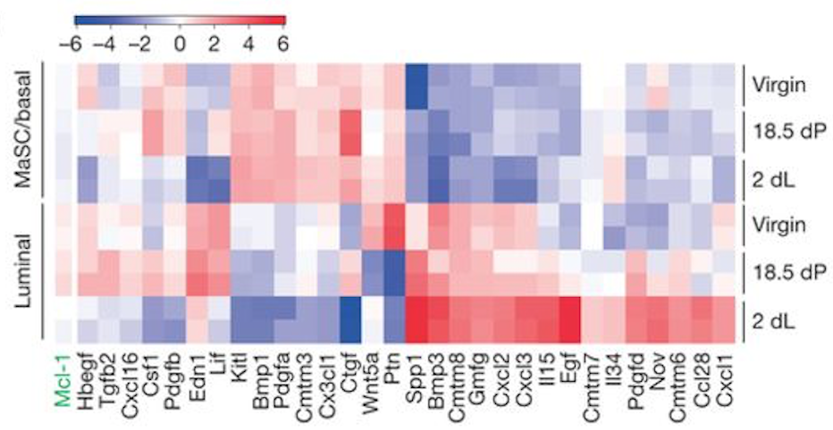
ChatGPT Data:
 | Mcl-1 | Hbegf | Tgfb2 | Cxcl16 | Csf1 | Pdgfb | Edn1 | Lif | Kitl | Bmp1 | Pdgfa | Cntn3 | Cx3cl1 | Ctgf | Wnt5a | Ptn | Spp1 | Bmp3 | Cntn8 | Gmfg | Cxcl2 | Cxcl3 | Il15 | Egf | Cntn7 | Il34 | Pdgfd | Nov | Cntn6 | Ccl28 | Cxcl1
MaSC/basal Virgin | -3 | -2 | -1 | 0 | 1 | 2 | 1 | 0 | -1 | -2 | -2 | 0 | -4 | -4 | 0 | 1 | 5 | 3 | 2 | 1 | 0 | -1 | 1 | 3 | 2 | 0 | 0 | 1 | 0 | -1 | -3
MaSC/basal 18.5 dP | -2 | -3 | -1 | 0 | 1 | 1 | 0 | -1 | -2 | -3 | -1 | -1 | -3 | -3 | 0 | 1 | 4 | 2 | 1 | 1 | 0 | 0 | 1 | 2 | 1 | 0 | 0 | 2 | 1 | 0 | -2
MaSC/basal 2 dL | -1 | -2 | 0 | 0 | 1 | 1 | 0 | 0 | -1 | -2 | 0 | -1 | -2 | -2 | 0 | 1 | 3 | 1 | 0 | 0 | 1 | 1 | 2 | 1 | 0 | 0 | 0 | 2 | 0 | 0 | -1
Luminal Virgin | 0 | 1 | 2 | 1 | 1 | 2 | 1 | 0 | -1 | -2 | 1 | 0 | -2 | -2 | -1 | -1 | 2 | 1 | 0 | 0 | 1 | 2 | 3 | 2 | 1 | 1 | 1 | 3 | 1 | 0 | -2
Luminal 18.5 dP | -1 | 0 | 1 | 1 | 1 | 1 | 0 | 0 | 0 | -1 | 0 | 0 | -1 | -1 | -1 | -1 | 1 | 1 | 1 | 1 | 1 | 2 | 3 | 3 | 2 | 2 | 2 | 4 | 1 | 1 | -1
Luminal 2 dL | -2 | -1 | 0 | 0 | 1 | 1 | 0 | 0 | 0 | -1 | -1 | -1 | -1 | -1 | -1 | 0 | 1 | 1 | 2 | 1 | 3 | 4 | 4 | 4 | 3 | 2 | 2 | 5 | 2 | 2 | 0

Perplexity Data:
 | Mcl-1 | Hbegf | Tgfb2 | Cxcl16 | Csf1 | Pdgfb | Edn1 | Lif | Kitl | Bmp1 | Pdgfa | Cmtm3 | Cx3cl1 | Ctgf | Wnt5a | Ptn | Spp1 | Bmp3 | Cmtm8 | Gmfg | Cxcl2 | Cxcl3 | Il15 | Egf | Cmtm7 | Il34 | Pdgfd | Nov | Cmtm6 | Ccl28 | Cxcl1
MaSC/basal Virgin | -1 | 1 | -2 | 0 | 1 | 1 | 0 | 0 | 0 | 0 | 1 | 0 | -4 | -5 | 0 | 1 | 5 | 0 | 0 | 0 | 0 | 0 | 0 | 4 | 0 | 0 | -1 | 0 | 0 | 0 | -2
MaSC/basal 18.5 dP | -1 | -2 | 1 | 1 | 1 | 0 | -1 | 0 | -1 | 0 | 1 | 0 | 0 | 0 | 0 | 1 | 0 | 0 | 0 | 0 | 0 | -1 | -2 | -1 | 0 | 0 | -2 | 0 | 0 | 0 | -1
MaSC/basal 2 dL | -1 | 1 | 0 | 0 | -1 | -1 | 0 | 0 | -1 | -1 | 1 | -1 | 0 | -1 | 0 | 1 | 0 | -1 | 0 | 0 | 0 | 1 | -2 | -1 | 0 | 0 | 0 | 0 | 0 | 0 | 0
Luminal Virgin | -1 | 1 | 2 | -1 | 1 | 1 | 0 | 0 | 0 | 0 | 1 | 0 | 0 | 0 | -2 | -2 | 0 | 0 | 0 | 0 | 0 | 0 | 0 | -1 | -1 | 0 | 0 | 3 | 0 | 0 | -2
Luminal 18.5 dP | -1 | -1 | -1 | 0 | 0 | 0 | -2 | 0 | 0 | 0 | 0 | 0 | 0 | 0 | 0 | 0 | 0 | 0 | 0 | 0 | 0 | 0 | 0 | 0 | 0 | 0 | -1 | 5 | 0 | 0 | 0
Luminal 2 dL | -1 | -1 | -1 | -1 | 1 | 1 | 0 | 0 | 0 | 0 | 0 | 0 | 0 | 0 | 0 | 0 | 4 | 0 | 0 | 0 | 0 | 4 | 0 | 4 | 0 | 0 | 0 | 5 | 0 | 0 | 0

Gemini Data:
 | Mcl-1 | Hbegf | Tgfb2 | Cxcl16 | Csf1 | Pdgfb | Edn1 | Lif | Kitl | Bmp1 | Pdgfa | Cmtm3 | Cx3cl1 | Ctgf | Wnt5a | Ptn | Spp1 | Bmp3 | Cmtm8 | Gmfg | Cxcl2 | Cxcl3 | Il15 | Egf | Cmtm7 | Il34 | Pdgfd | Nov | Cmtm6 | Ccl28 | Cxcl1
MaSC/basal Virgin | -1 | 0 | -0.5 | 1 | 2 | -1.5 | 0.5 | -2 | 1.5 | -1 | 0 | 2.5 | -0.5 | 1 | -2.5 | 0 | -3 | 1.5 | -1 | 2 | -2 | 3 | -0.5 | 1 | -3.5 | 0 | 2.5 | -1.5 | 1 | -2 | 3.5
MaSC/basal 18.5 dP | -2 | 1 | -1.5 | 0 | 1 | -0.5 | 1.5 | -1 | 0.5 | 0 | -1 | 1.5 | 0.5 | 2 | -1.5 | 1 | -2 | 0.5 | 0 | 1 | -1 | 2 | 0.5 | 2 | -2.5 | -1 | 1.5 | -0.5 | 0 | -1 | 2.5
MaSC/basal 2 dL | -3 | 2 | -2.5 | -1 | 0 | 0.5 | 2.5 | 0 | -0.5 | 1 | -2 | 0.5 | 1.5 | 3 | -0.5 | 2 | -1 | -0.5 | 1 | 0 | 0 | 1 | 1.5 | 3 | -1.5 | -2 | 0.5 | 0.5 | -1 | 0 | 1.5
Luminal Virgin | -0.5 | 0.5 | 0 | 1.5 | 2.5 | -2 | 0 | -2.5 | 2 | -1.5 | 0.5 | 3 | -1 | 0.5 | -3 | -0.5 | -3.5 | 2 | -1.5 | 2.5 | -2.5 | 3.5 | -1 | 0.5 | -4 | 0.5 | 3 | -2 | 1.5 | -2.5 | 4
Luminal 18.5 dP | -1 | 1.5 | -1 | 0.5 | 1.5 | -1 | 1 | -1.5 | 1 | -0.5 | -0.5 | 2 | 0 | 1.5 | -2 | 0.5 | -2.5 | 1 | -0.5 | 1.5 | -1.5 | 2.5 | 0 | 1.5 | -3 | -0.5 | 2 | -1 | 0.5 | -1.5 | 3
Luminal 2 dL | -2 | 2.5 | -2 | -0.5 | 0.5 | 0 | 2 | -0.5 | 0 | 0.5 | -1.5 | 1 | 1 | 2.5 | -1 | 1.5 | -1.5 | 0 | 0.5 | 0.5 | -0.5 | 1.5 | 1 | 2.5 | -2 | -1.5 | 1 | 0 | -0.5 | -0.5 | 2

Figure 19:
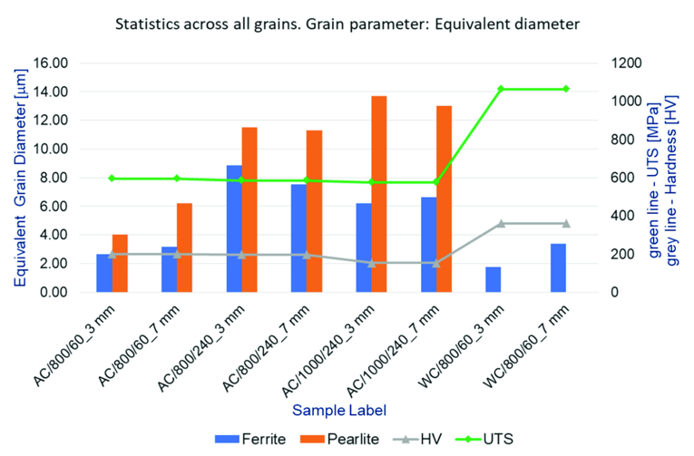

ChatGPT Data:
Label | Ferrite (µm) | Pearlite (µm) | Hardness (HV) | UTS (MPa)
AC/800/60_3mm | 2.5 | 5 | 200 | 800
AC/800/60_7mm | 3 | 6 | 220 | 810
AC/800/240_3mm | 3.5 | 10 | 250 | 805
AC/800/240_7mm | 4 | 12 | 240 | 820
AC/1000/240_3mm | 3.8 | 11 | 230 | 815
AC/1000/240_7mm | 4.2 | 13 | 260 | 825
WC/800/60_3mm | 1.8 | 3.5 | 280 | 1000
WC/800/60_7mm | 2.2 | 4 | 300 | 1050

Perplexity Data:
Sample Label | Ferrite [μm] | Pearlite [μm] | Hardness HV | UTS [MPa]
AC/800/60_3 mm | 2 | 6 | 200 | 500
AC/800/60_7 mm | 4 | 8 | 220 | 520
AC/800/240_3 mm | 3 | 7 | 240 | 540
AC/800/240_7 mm | 5 | 10 | 260 | 560
AC/1000/240_3 mm | 4 | 8 | 280 | 580
AC/1000/240_7 mm | 6 | 12 | 300 | 600
WC/800/60_3 mm | 3 | 6 | 320 | 800
WC/800/60_7 mm | 8 | 10 | 340 | 1000

Gemini Data:
Sample Label | Ferrite Diameter [µm] | Pearlite Diameter [µm] | Hardness HV | UTS [MPa]
AC/800/60_3 mm | 2.6 | 4 | 240 | 600
AC/800/60_7 mm | 2.8 | 6.2 | 220 | 580
AC/800/240_3 mm | 8.8 | 11.6 | 220 | 580
AC/800/240_7 mm | 8 | 11.2 | 220 | 580
AC/1000/240_3 mm | 6.2 | 13.6 | 220 | 580
AC/1000/240_7 mm | 6.6 | 10.4 | 220 | 580
WC/800/60_3 mm | 1.8 | 14.4 | 480 | 1020
WC/800/60_7 mm | 3.4 | 0 | 500 | 1020

Figure 20:
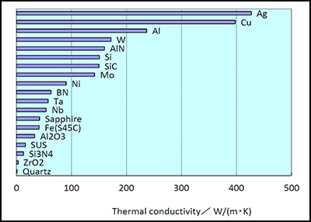

ChatGPT Data:
Material | Thermal Conductivity (W/m·K)
Quartz | 5
ZrO₂ | 10
Si₃N₄ | 15
SUS | 20
Al₂O₃ | 25
Fe(S45C) | 30
Sapphire | 40
Nb | 55
Ta | 60
BN | 80
Ni | 90
Mo | 110
SiC | 120
Si | 150
AlN | 170
W | 175
Al | 235
Cu | 400
Ag | 430

Perplexity Data:
Material | Thermal Conductivity (W/m·K)
Ag | 430
Cu | 400
Al | 230
W | 170
AlN | 160
Si | 150
SiC | 120
Mo | 110
Ni | 90
BN | 80
Ta | 60
Nb | 50
Sapphire | 40
Fe(S45C) | 30
Al2O3 | 25
SUS | 20
Si3N4 | 15
ZrO2 | 10
Quartz | 5

Gemini Data:
Material | Thermal Conductivity (W/m·K)
Ag | 429
Cu | 401
Al | 237
W | 173
AlN | 170
Si | 148
Mo | 138
SiC | 120
Ni | 90
Ta | 54
Nb | 54
Fe(S45C) | 50
Sapphire | 35
BN | 30
Al₂O₃ | 30
SUS | 16
Si₃N₄ | 15
ZrO₂ | 2
Quartz | 1.4

Figure 21:
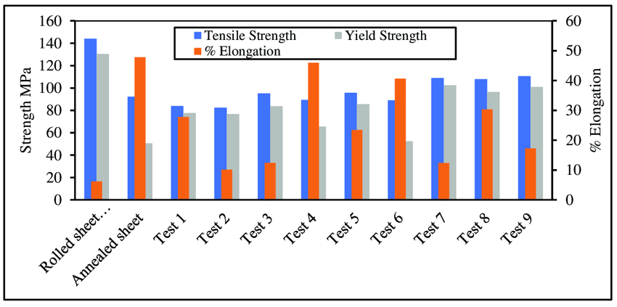
ChatGPT Data:
Test Condition | Tensile Strength (MPa) | Yield Strength (MPa) | % Elongation
Rolled sheet | 145 | 95 | 15
Annealed sheet | 90 | 45 | 125
Test 1 | 85 | 75 | 25
Test 2 | 80 | 70 | 35
Test 3 | 75 | 65 | 30
Test 4 | 70 | 60 | 55
Test 5 | 90 | 80 | 30
Test 6 | 100 | 85 | 40
Test 7 | 110 | 95 | 25
Test 8 | 115 | 90 | 20
Test 9 | 120 | 85 | 15
Perplexity Data:
Test Condition | Tensile Strength (MPa) | Yield Strength (MPa) | % Elongation
Rolled Sheet | 145 | 130 | 8
Annealed Sheet | 90 | 55 | 45
Test 1 | 82 | 78 | 28
Test 2 | 82 | 78 | 10
Test 3 | 95 | 85 | 12
Test 4 | 88 | 68 | 45
Test 5 | 95 | 85 | 22
Test 6 | 88 | 50 | 40
Test 7 | 108 | 102 | 12
Test 8 | 108 | 95 | 30
Test 9 | 108 | 95 | 15

Gemini Data:
Sample | Tensile Strength (MPa) | Yield Strength (MPa) | % Elongation
Rolled sheet | 145 | 130 | 5
Annealed sheet | 130 | 115 | 45
Test 1 | 85 | 75 | 25
Test 2 | 82 | 78 | 5
Test 3 | 95 | 85 | 10
Test 4 | 90 | 80 | 42
Test 5 | 95 | 88 | 22
Test 6 | 108 | 90 | 38
Test 7 | 105 | 92 | 12
Test 8 | 108 | 95 | 25
Test 9 | 110 | 98 | 15

Figure 22:
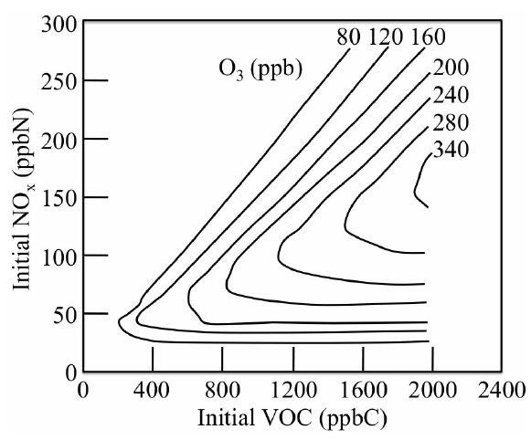
ChatGPT Data:
VOC (ppbC) | NOx (ppbN) | O₃ (ppb)
0 | 0 | 80
0 | 60 | 80
0 | 120 | 80
0 | 180 | 80
0 | 240 | 80
600 | 0 | 80
600 | 60 | 110
600 | 120 | 130
600 | 180 | 140
600 | 240 | 150
1200 | 0 | 80
1200 | 60 | 160
1200 | 120 | 180
1200 | 180 | 200
1200 | 240 | 210
1800 | 0 | 80
1800 | 60 | 210
1800 | 120 | 230
1800 | 180 | 250
1800 | 240 | 260
2400 | 0 | 80
2400 | 60 | 240
2400 | 120 | 260
2400 | 180 | 280
2400 | 240 | 300

Perplexity Data:
VOC (ppbC) | NOx (ppbN) | O₃ (ppb)
400 | 0 | 0
400 | 50 | 30
400 | 100 | 60
400 | 150 | 80
400 | 200 | 100
400 | 250 | 120
1200 | 0 | 0
1200 | 50 | 80
1200 | 100 | 120
1200 | 150 | 160
1200 | 200 | 200
1200 | 250 | 240
2000 | 0 | 0
2000 | 50 | 70
2000 | 100 | 100
2000 | 150 | 130
2000 | 200 | 170
2000 | 250 | 210
2400 | 0 | 0
2400 | 50 | 60
2400 | 100 | 90
2400 | 150 | 120
2400 | 200 | 150
2400 | 250 | 180

Gemini Data:
VOC (ppbC) | NOx (ppbN) | O₃ (ppb)
0 | 0 | 20
0 | 60 | 20
0 | 120 | 20
0 | 180 | 20
0 | 240 | 20
600 | 0 | 40
600 | 60 | 80
600 | 120 | 100
600 | 180 | 110
600 | 240 | 120
1200 | 0 | 60
1200 | 60 | 120
1200 | 120 | 140
1200 | 180 | 150
1200 | 240 | 160
1800 | 0 | 80
1800 | 60 | 160
1800 | 120 | 180
1800 | 180 | 190
1800 | 240 | 200
2400 | 0 | 100
2400 | 60 | 200
2400 | 120 | 220
2400 | 180 | 240
2400 | 240 | 260

Figure 23:
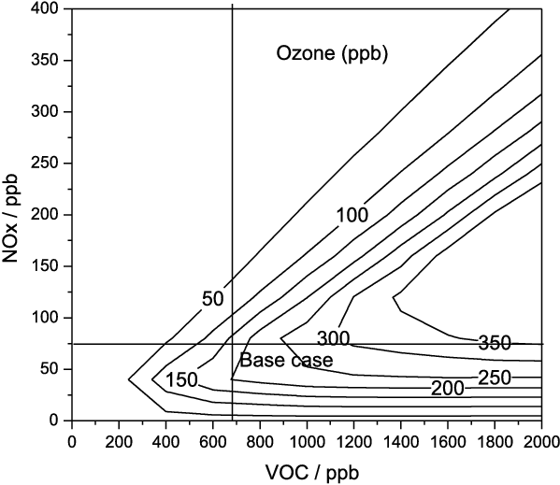
ChatGPT Data:
VOC (ppb) | NOx (ppb) | Ozone (ppb)
0 | 0 | 60
0 | 100 | 48
0 | 200 | 12
0 | 300 | -48
0 | 400 | -132
500 | 0 | 58
500 | 100 | 109
500 | 200 | 85
500 | 300 | -13
500 | 400 | -145
1000 | 0 | 45
1000 | 100 | 120
1000 | 200 | 140
1000 | 300 | 105
1000 | 400 | 16
1500 | 0 | 20
1500 | 100 | 121
1500 | 200 | 170
1500 | 300 | 165
1500 | 400 | 106
2000 | 0 | -15
2000 | 100 | 112
2000 | 200 | 170
2000 | 300 | 185
2000 | 400 | 156

Perplexity Data:
VOC (ppb) | NOx (ppb) | Ozone (ppb)
0 | 0 | 150
0 | 100 | 185
0 | 200 | 220
0 | 300 | 250
0 | 400 | 276
500 | 0 | 220
500 | 100 | 245
500 | 200 | 270
500 | 300 | 292
500 | 400 | 312
1000 | 0 | 250
1000 | 100 | 265
1000 | 200 | 280
1000 | 300 | 294
1000 | 400 | 307
1500 | 0 | 260
1500 | 100 | 270
1500 | 200 | 280
1500 | 300 | 290
1500 | 400 | 299
2000 | 0 | 263
2000 | 100 | 270
2000 | 200 | 277
2000 | 300 | 284
2000 | 400 | 291

Gemini Data:
VOC (ppb) | NOx (ppb) | Ozone (ppb)
200 | 50 | 100
400 | 100 | 50
600 | 150 | 50
800 | 200 | 50
1000 | 250 | 100
1200 | 300 | 150
1400 | 350 | 200
1600 | 400 | 250
1800 | 400 | 300
2000 | 400 | 350

Figure 24:
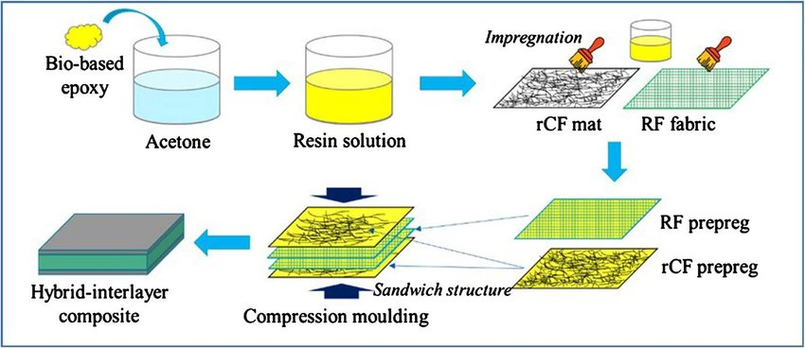

Step | Schematic Description (ChatGPT) | Schematic Description (Perplexity)
1 | Bio-based epoxy | Mix bio-based epoxy with acetone.
2 | Acetone | Create a resin solution.
3 | Resin solution | Impregnate rCF mat and RF fabric with the resin solution.
4 | Impregnation | Obtain RF prepreg and rCF prepreg.
5 | RF prepreg, rCF prepreg | Create a sandwich structure.
6 | Compression moulding (Hybrid-interlayer composite) | Use compression molding to form the hybrid-interlayer composite.

